.one Overview

XIDNA

Detailing the one technology configurations

2021

Poovanna Chekkera

8020 systems pvt ltd

10/8/2021

Contents

Document History 3

Introduction to design Studio: 4

.one: 4

Object management: 5

Attributes: 6

Option List: 6

Groups: 7

Layout Management: 7

Layout Details: 9

Layout Mapping: 10

Dialog Mangement: 11

XiLinks: 12

Question set link: 12

Dialog link: 14

Components: 15

Data Types: 15

Data source 17

Question Set: 17

QuestionSet Fields: 18

Question set: 23

QS Links: 32

List view in Question set: 33

Configuration Studio: 34

Menu: 34

Map menu: 35

1-Clicks: 36

# Document History

|  |  |  |  |
| --- | --- | --- | --- |
| Date | What | Notes |  |
| 2021.10.08 | Created | .one Technology |  |
|  |  |  |  |
|  |  |  |  |
|  |  |  |  |
|  |  |  |  |
|  |  |  |  |
|  |  |  |  |

# Introduction to design Studio:

The one technology overview briefs all the configuration nodes in the system, Login to the “.one Design Studio” using link(<https://183.82.123.14/InsureOne/onedesignstudio>) with admin credentials. The first node which is the parent node in the tree has ‘.one(onedesignstuido)’ which indicates that its ‘.one design studio’. The design studio is divided into three parts,

1. Tree,
2. Grid,
3. Form.

The parent node ‘.one’ has child nodes and sub child nodes which are explained below.

## .one:

Click on the node to view the application, grid displays the selected application list that has been created with edit form, right click on the node and ‘clear’ that will display all the application with create form to create new application and this remains same for all nodes to display and create.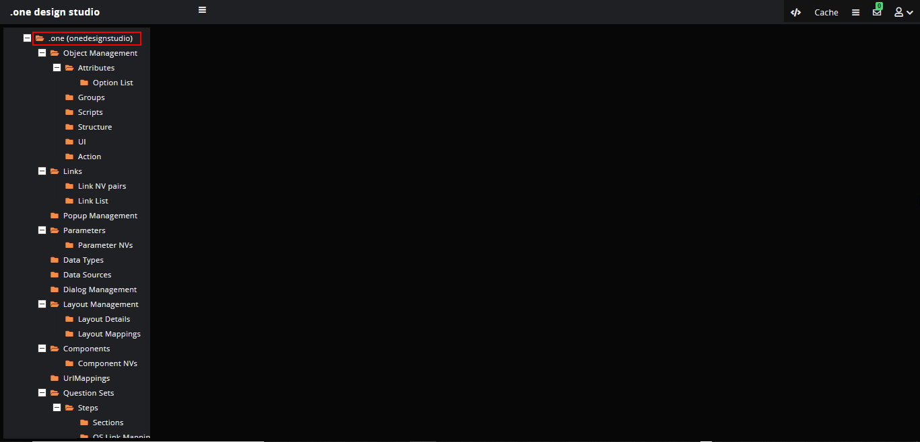

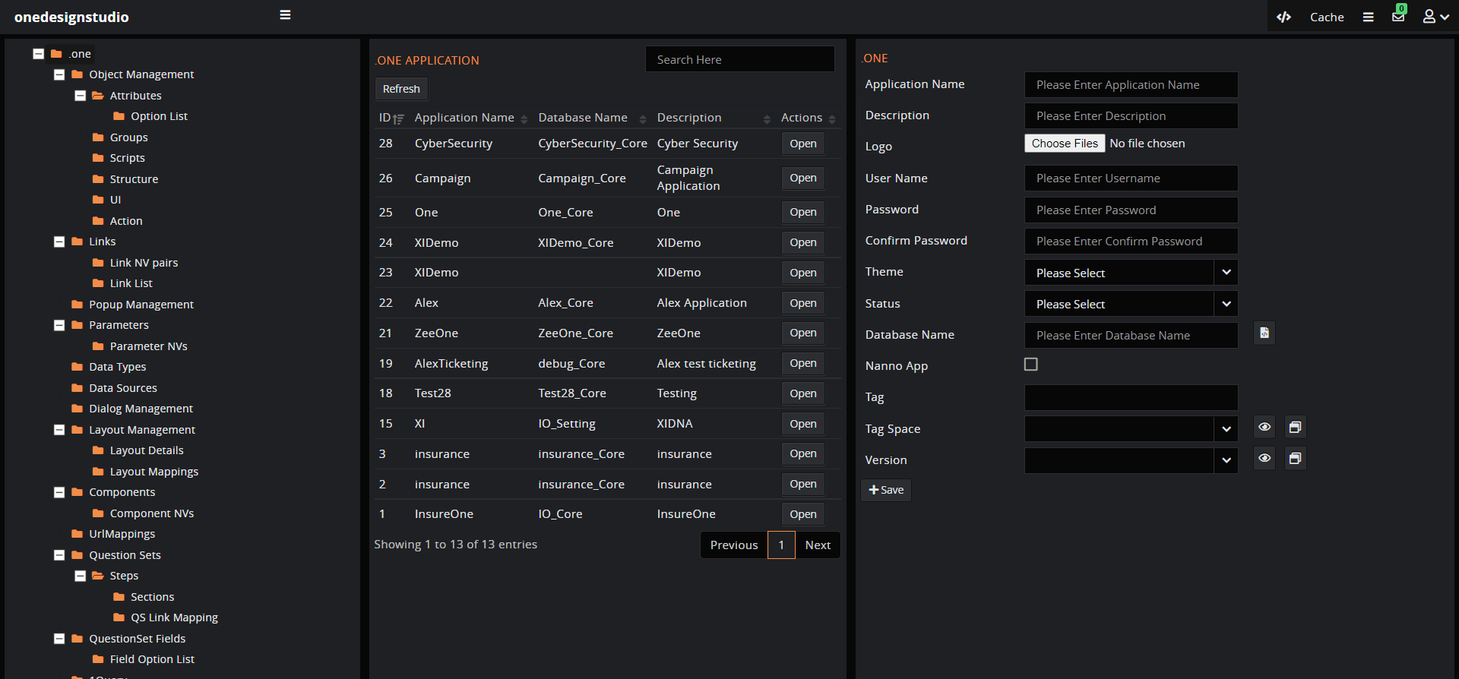

The application created has its own studio called ‘Developer Studio’ to create the organisation etc but always a default organisation will get created for a application with three logins,

* Application login.
* Developer studio,
* Config studio.

*Note: Always select the values based on the node to create its relative fields, for example to create a object for application select the application and create a object.*

## Object management:

An object when used in object-oriented programming, is a representation of parts of a business. Click on the ‘Object management’ to create new object, on success it will by default create,

* Attributes,
* Groups,
* Menu,
* Layout,
* Dialog,
* Xilink,
* 1-click,
* Layout mapping.

The default items created are shown below while explaining different concepts.

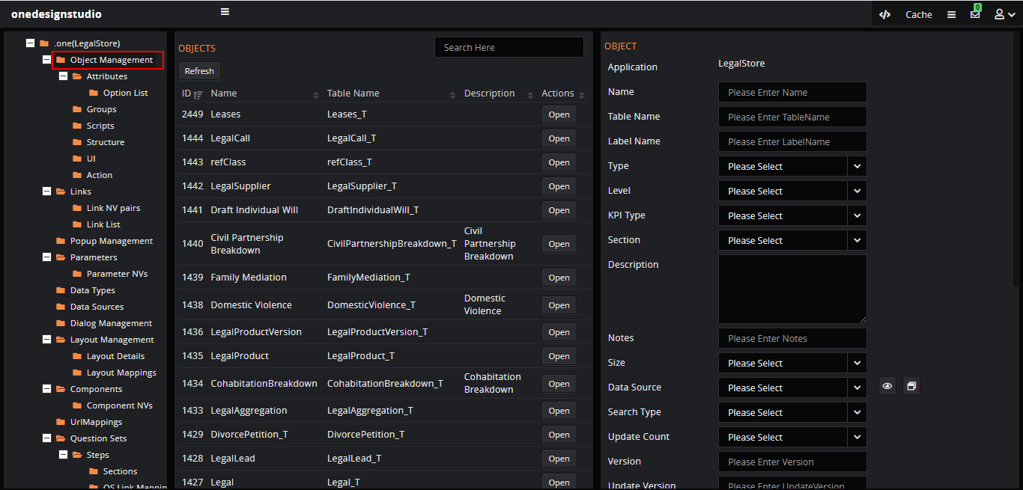

Fill the form and click on ‘Save’ to create a new object, If the object is created, it will get added in the grid where we can click on it to select.

Steps to create an object,

1. Select the application from ‘.one’.
2. Click on the ‘Object Management’.
3. Fill in the form details like table, type, source, Primary key/GUID etc.
4. Select the object status as ‘Active’.

### Attributes:

Attribute is a piece of information which determines the properties of a field or tag in a database or a string of characters in a display. We can create the attributes for the ‘Object’ some default attributes get created when we created the object.

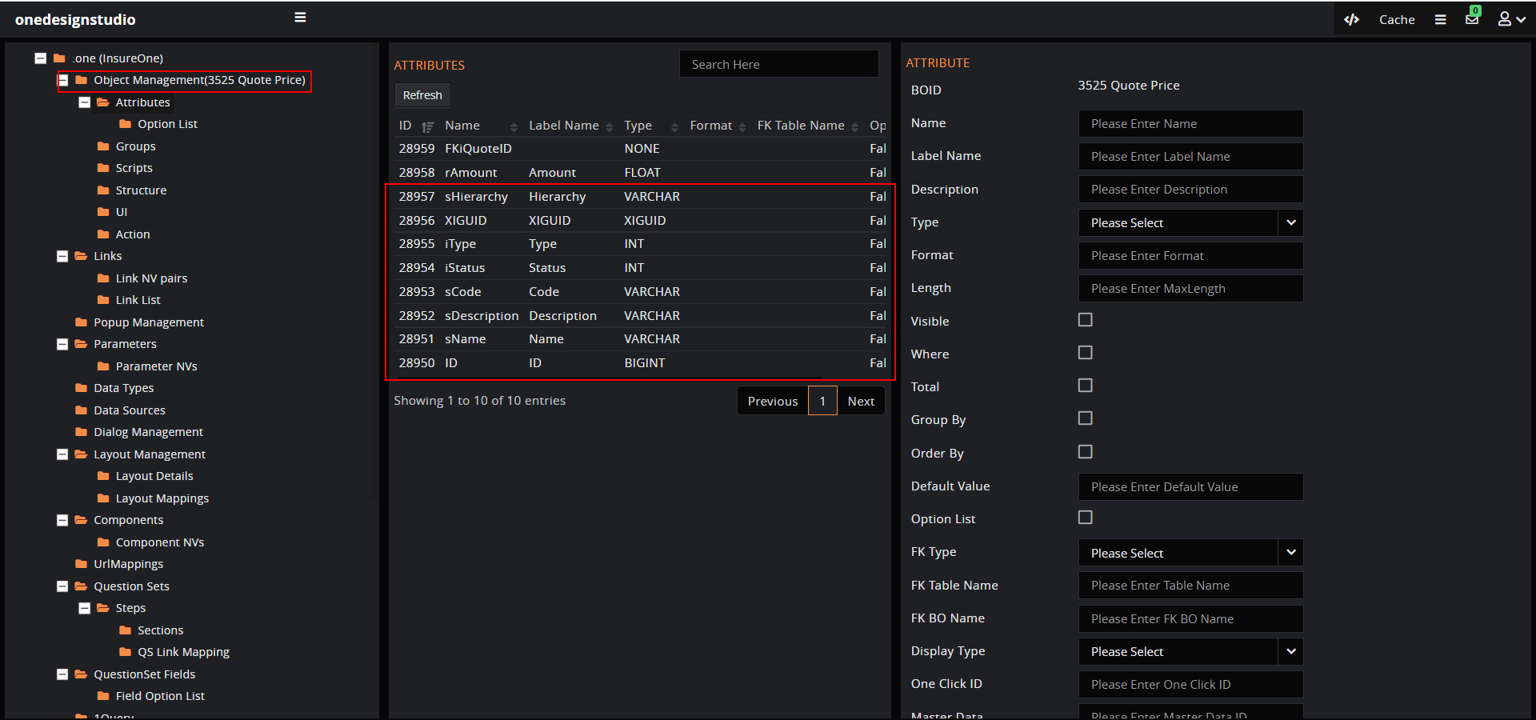

Fill the form details, click on the ‘Save’ button to create a new attribute. We can create types of attributes required, for example if we want to create an option list then check the check box provided in the form.

Steps to create an Attribute,

1. Select the object from ‘Object Management’.
2. Expand the object management and click on the ‘Attributes’.
3. Fill in the form details like Size, datatype, option list, FK etc.
4. Select the status as active.

### Option List:

If the option list is checked for attribute, then select the attribute click on the ‘Option List’ which is the child node of the attribute.

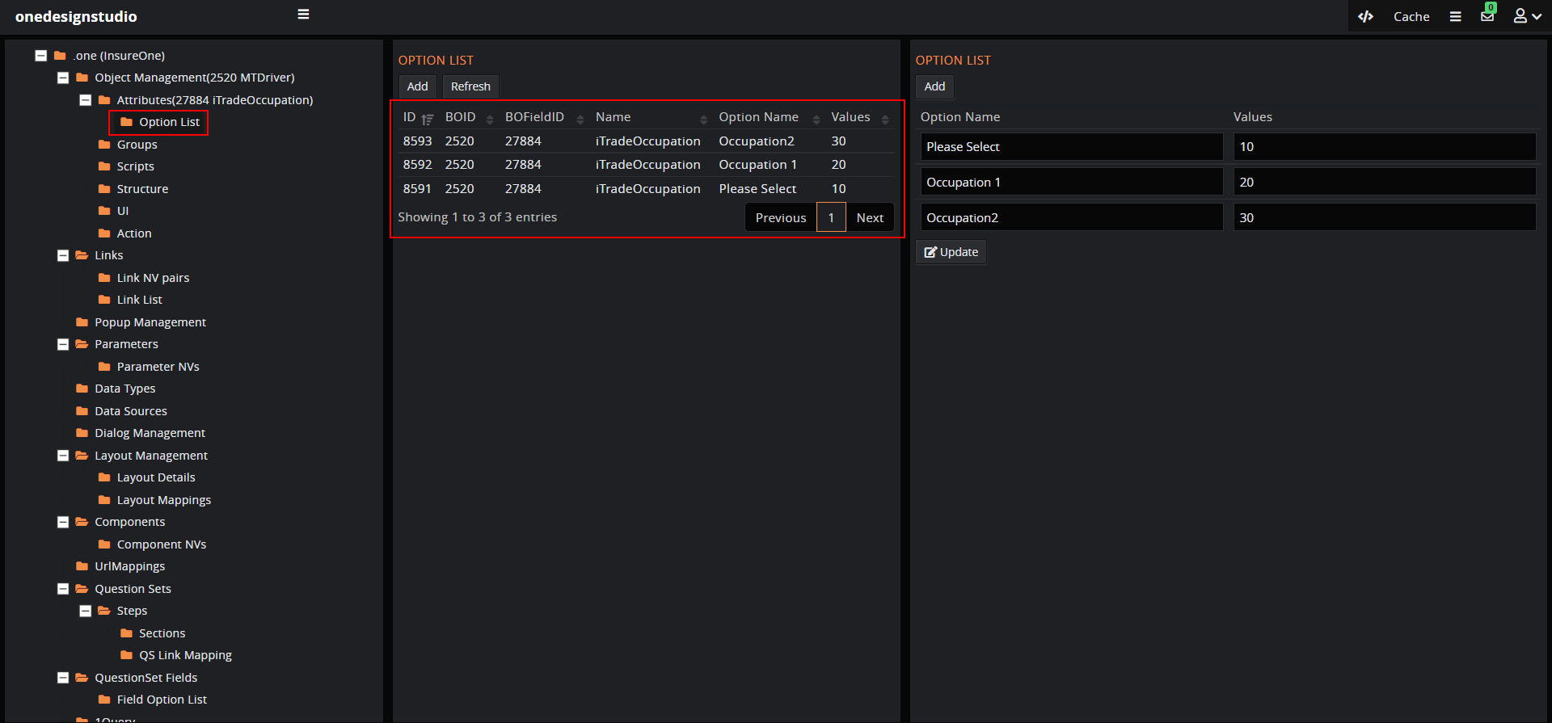

### Groups:

By creating the group, we are grouping the attributes of the object with a uinque name that can be used while creating 1-Click queries etc.

To create a group, select the object and click on the ‘Group’ node there are few default groups created with default attributes.

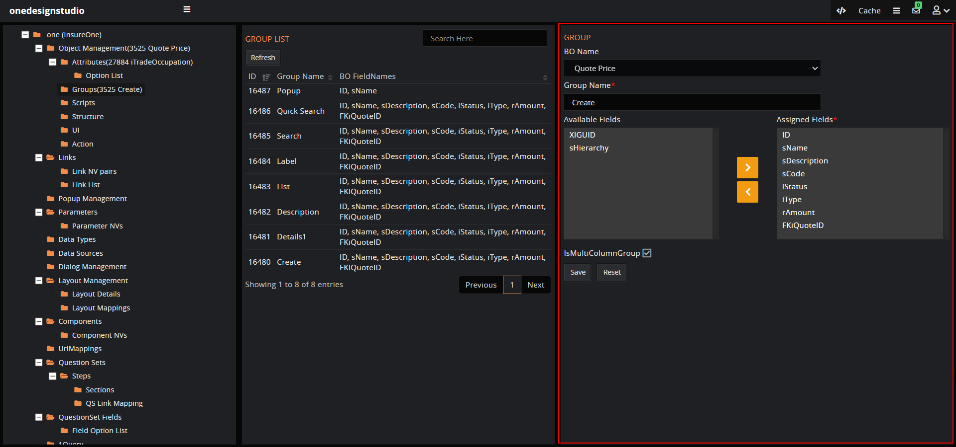

Follow steps for creating a new group,

* Enter the group name.
* In the available fields double click on the attributes to assign the fields or click to select the field and use arrows to select/ delect.
* Click on ‘Save’ button.

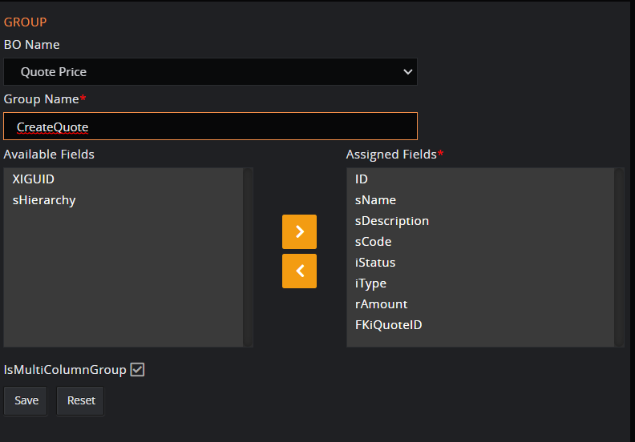

## Layout Management:

Layout is the base for displaying the contents for the user on the dialog. There are default layouts created when we create the objects.

To create the new layout,

1. Click on the ‘Layout Management’
2. Select the ‘Level’ as 'Organisation/Application', ‘Type’ as 'dialog' and ‘Authentication’ as ‘Authunicated’.
3. Enter the ‘Layout Code’, <div class="row"><div class="col-md-12" id="1"></div></div>

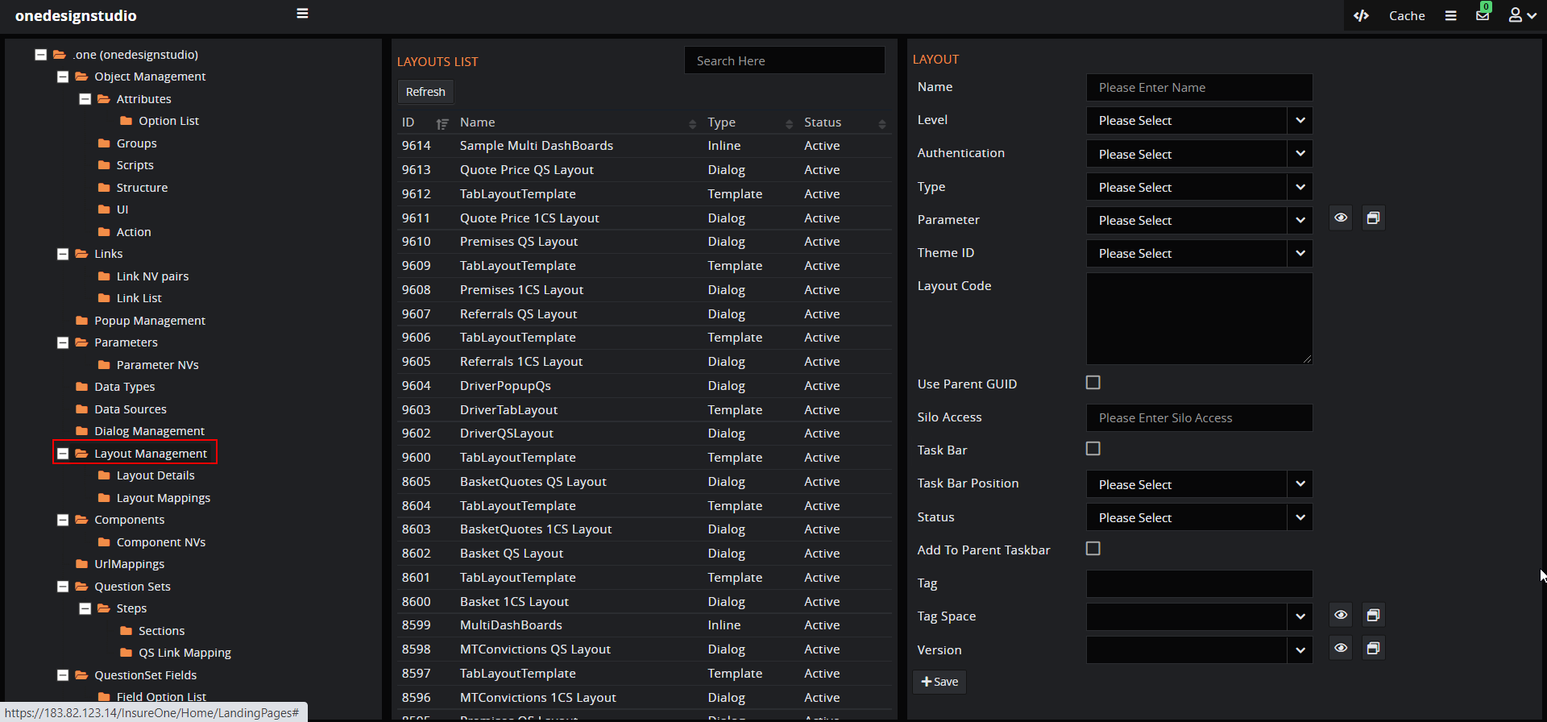

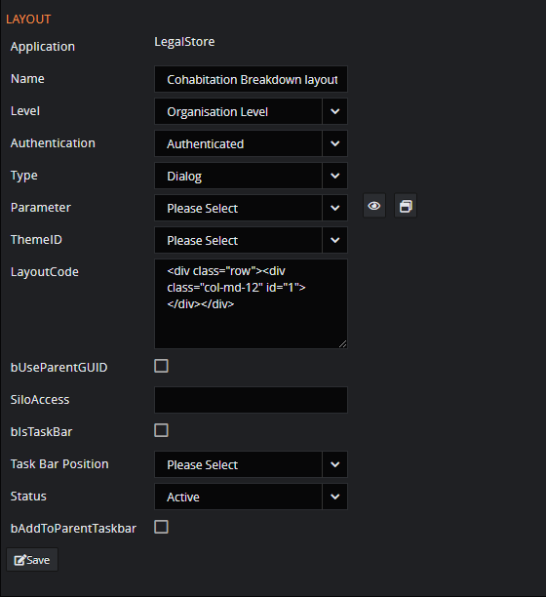

Select the layout created.

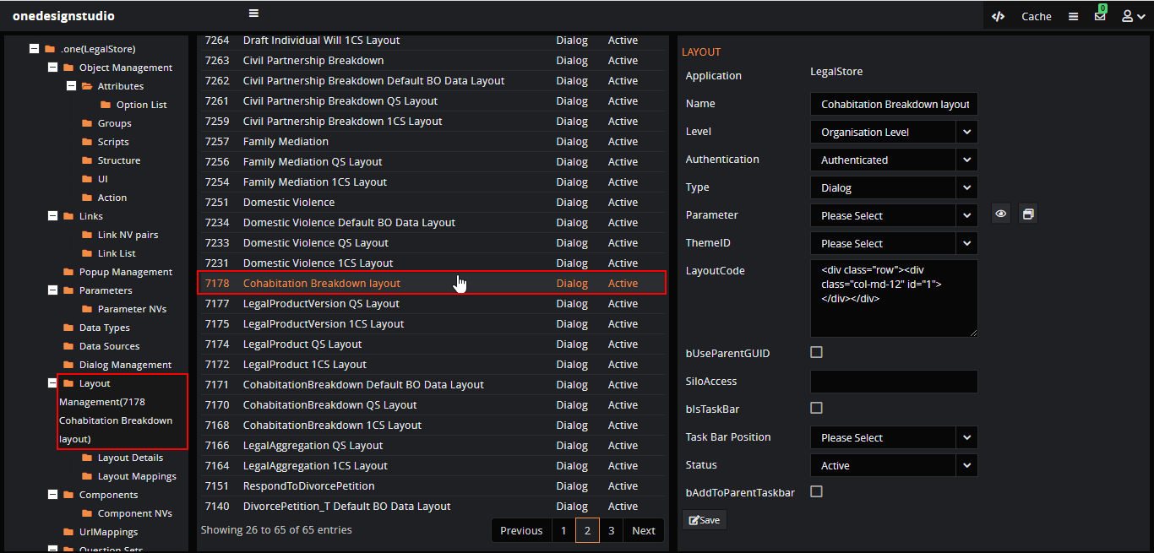

### Layout Details:

Add unique details like name and placeholder for the layout.

To add the details,

1. Select the layout from ‘Layout Management’.
2. Click on the ‘Layout Details’.
3. Click on the layout and enter the unique ‘Name’ and ‘Placeholder’.

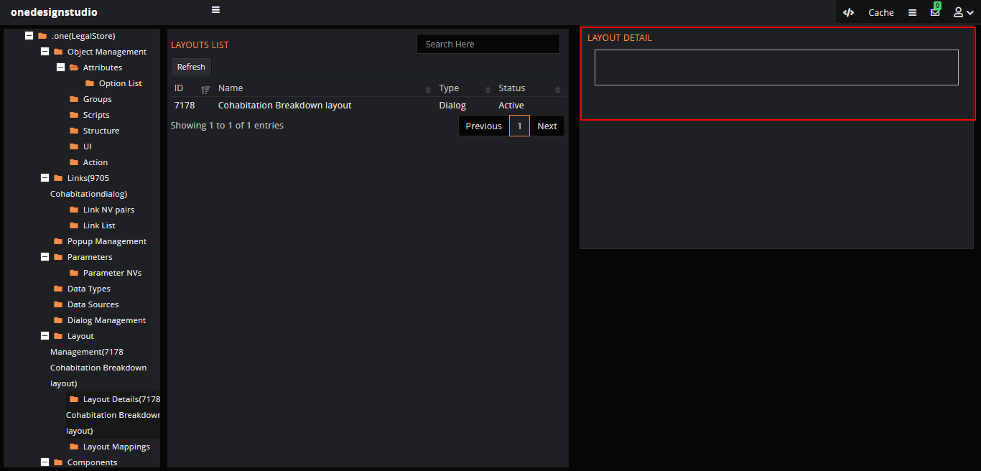

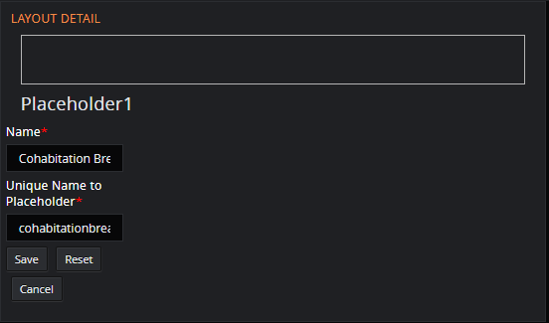

### Layout Mapping:

We can map the required details to the layout with ‘Layout Mapping’, for example the xilink created for the question set can be mapped to the layout.

*Note: Layout mapping can be done after creating the dialog.*

To map the details,

1. Select the layout form ‘Layout Management’.
2. Click on ‘Layout Mapping’.
3. Click on the layout displayed with name.
4. Select the ‘Type’ as ‘X Link’ and choose the xilink.

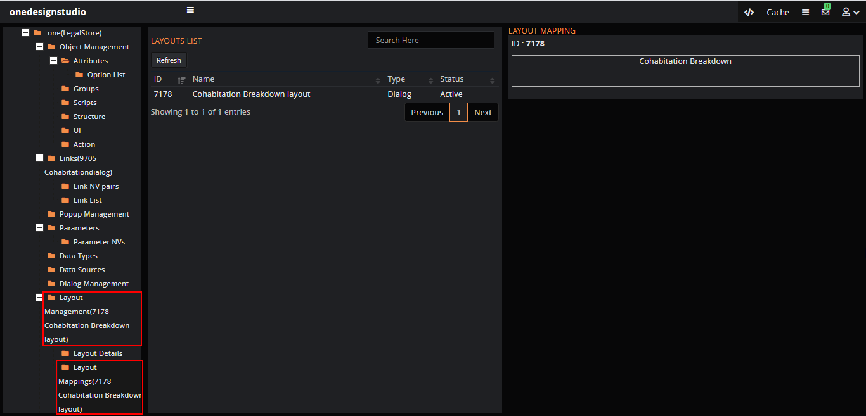

Click on the layout to add details.

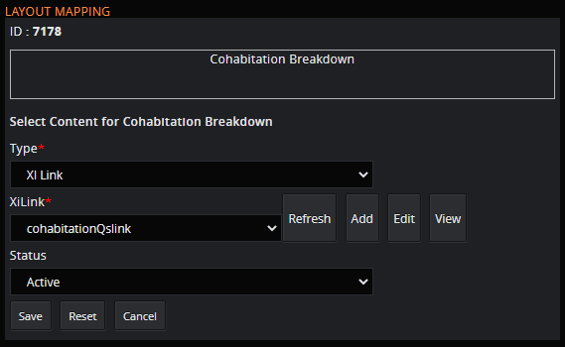

## Dialog Mangement:

The ‘Dialog management’ is the other name for the popup management, in the design or developer studio click on the ‘Dialog Management’ to create a dialog which is base for displaying the content in the structure called layout.

To create a dialog,

* Layout is mandatory for the dialog; it can be split into parts to display the content.
* Dailog can have icons such as maximize, minimize, close...etc
* As per the requirement we can set the positions and dimensions.
* The dialog positon can be default with predefined details or can be set manually with details for top, left, center, bottom...etc.
* To display the content in the dialog, the dialog should have layouts in layouts we have components, in components we can map the actual content.

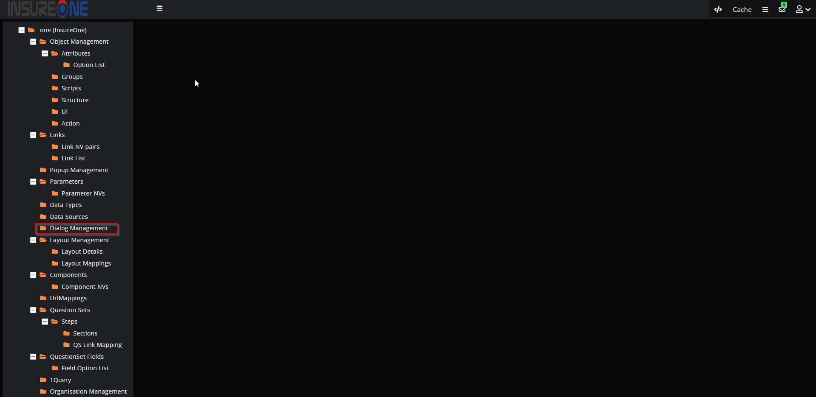

## XiLinks:

The ‘XiLinks’ can be used to link different things such as configuring dialogues, components, question set and controller methods.

To create links,

1. Click on the ‘Links’ to create the xilink.
2. Enter the ‘Name’ and ‘Type’ for example 'Content' for dialog and 'Questionset' for QS.
3. Select the status as ‘Active’.

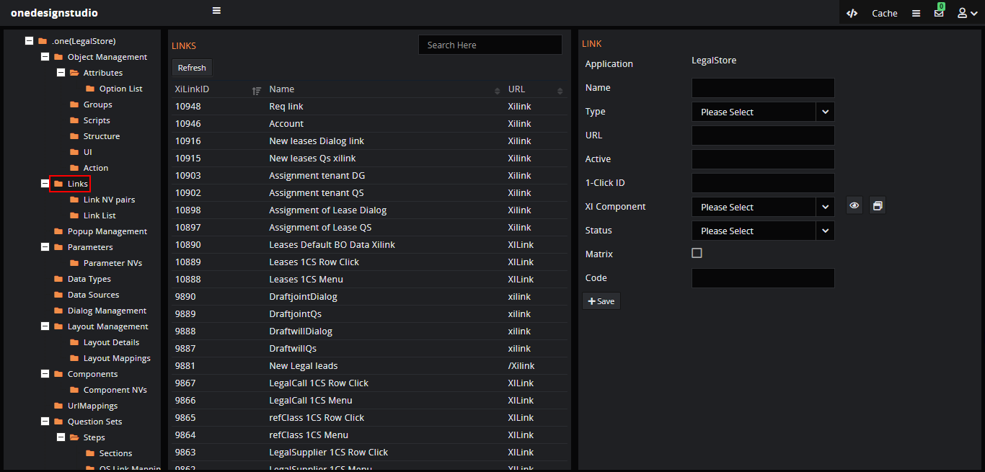

For example, let’s create two xilinks,

1. Question set
2. Dialog

### Question set link:

Enter the details and ‘Type’ as ‘Content’ to create the link for QS and click on the ‘Save’ button.

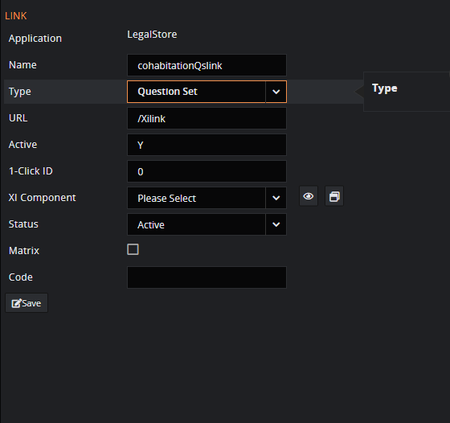

Select the link created for the questionset and click on ‘Link NV Pairs’ to create the name and value pairs for the xilink.

For QS the NV looks like: StartAction 🡪 QuestionSet

QuestionSetID 🡪 ‘3305’(for example)

sQSType 🡪Internal 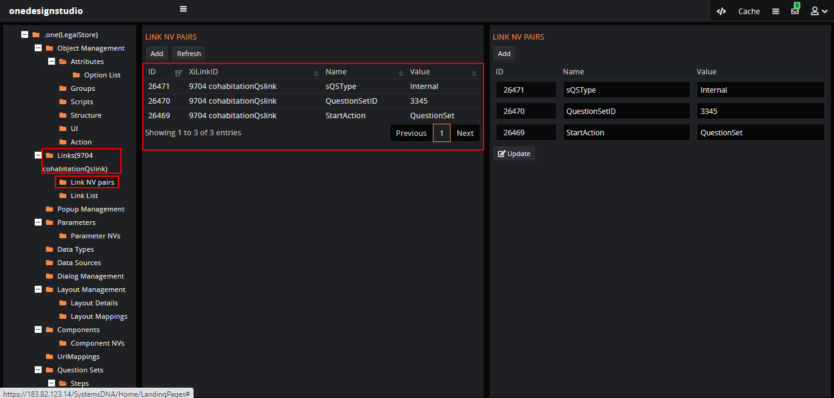

### Dialog link:

Enter the details and ‘Type’ as ‘Content’ to create the link for the dialog.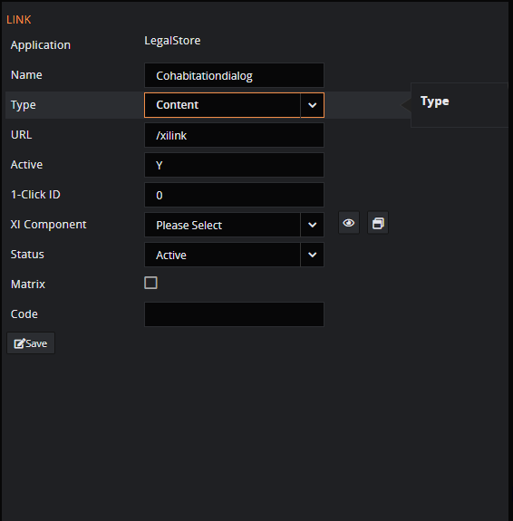

Select the link created for the dialog and click on ‘Link NV Pairs’ to create the name and value pairs for the xilink.

For dialog the NV looks like:

StartAction 🡪 Dialog

DialogID 🡪 ‘7000’ (for example)

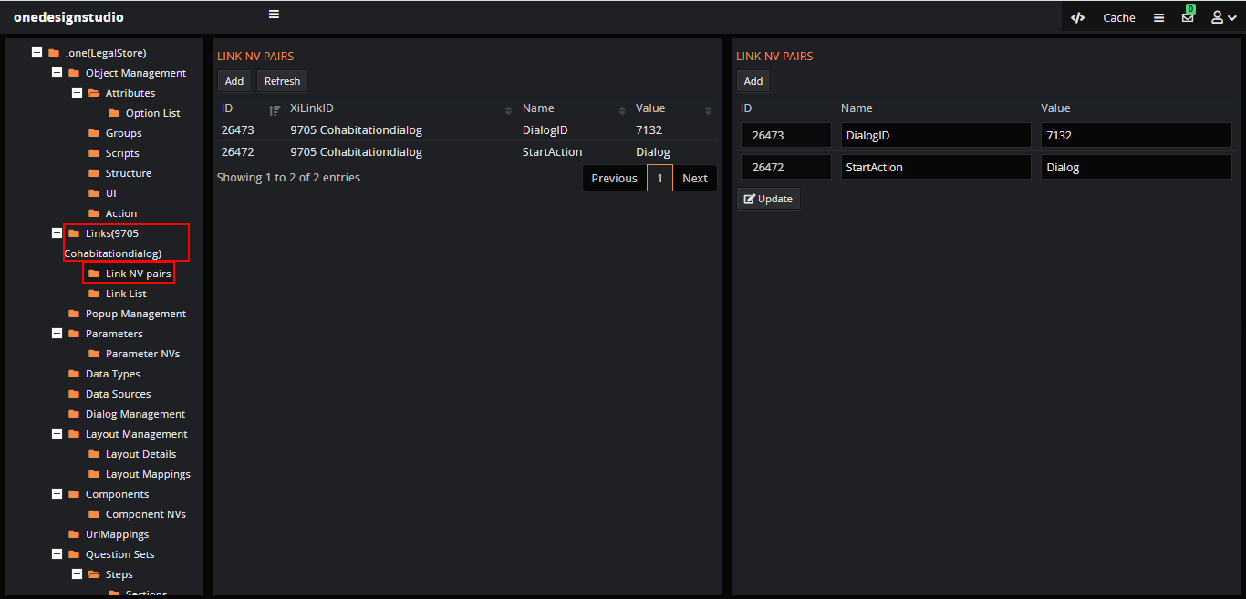

## Components:

We can create any number of components as per the requirement or use the existing components such as ‘Form components’, ‘Tree component’, ‘1Clickcomponent’, ‘Grid component’...etc

To create a component, click on the ‘Components’ node and fill in the details such as

* Name, the name of the component.
* Type, component type i.e., ‘External/internal’.
* Class, it is the path of the class where the component code is written.
* HTML Page, is the path of the view for that component class.

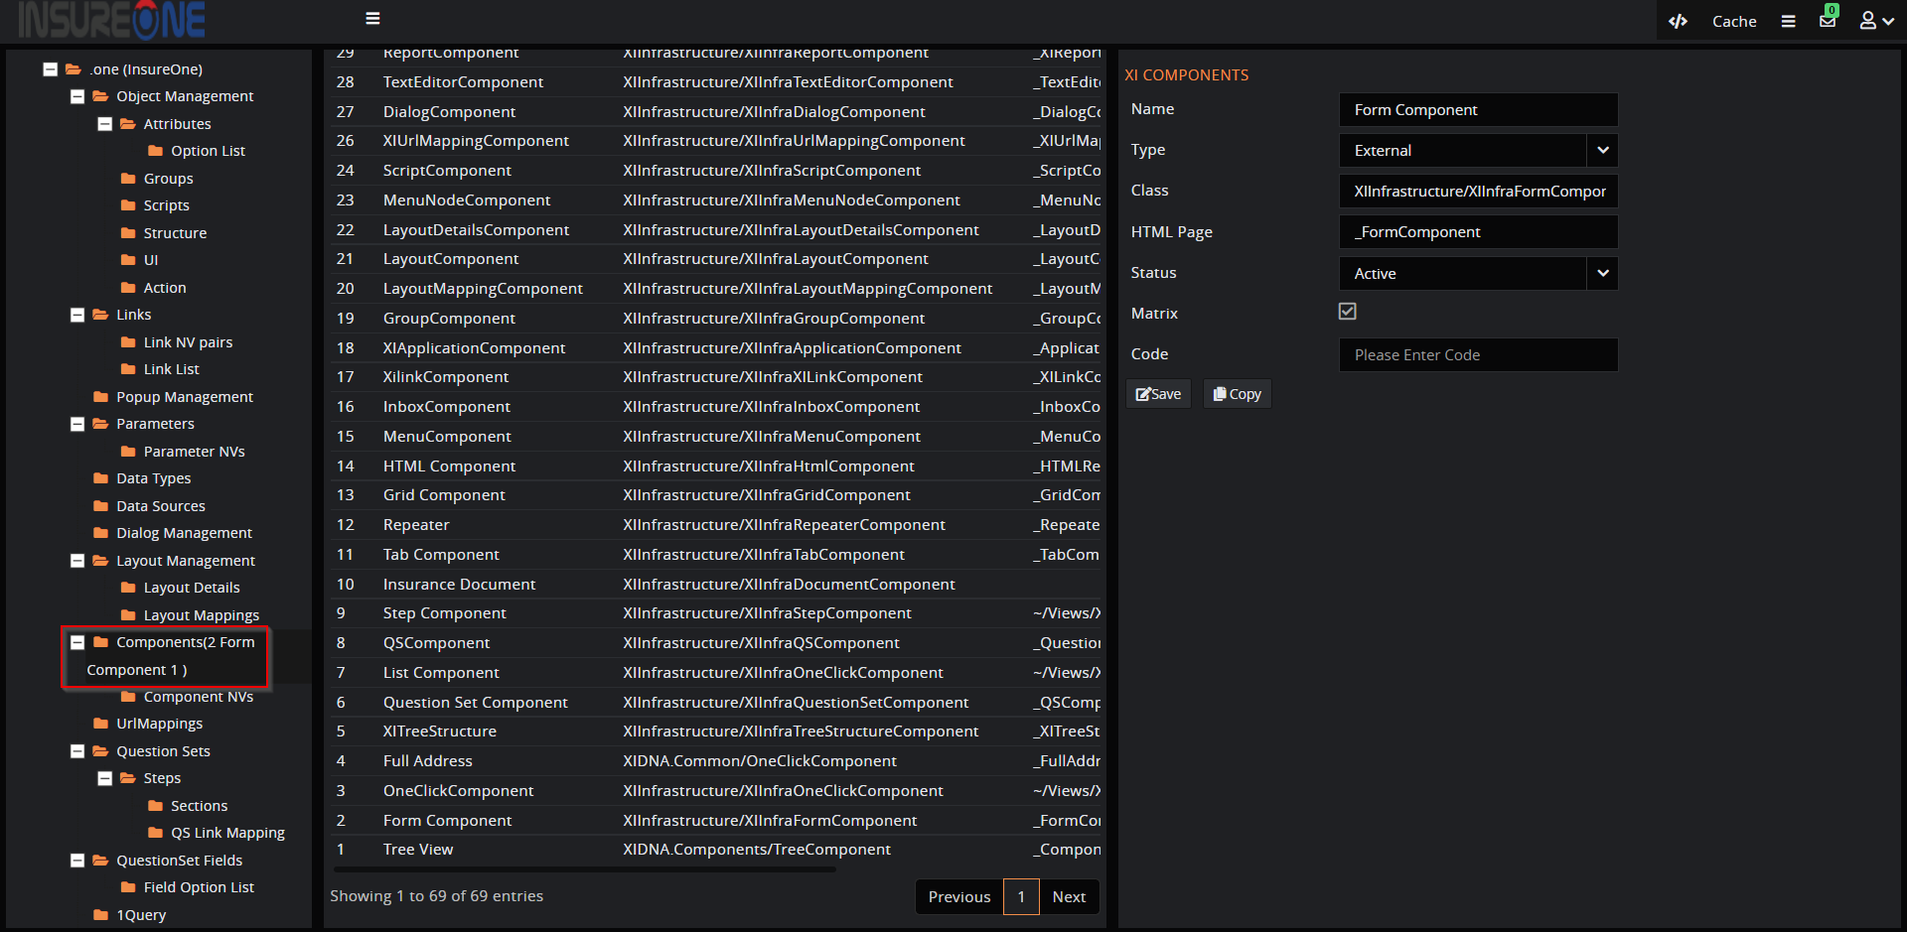

The name value pairs of the field for the component can be defined in ‘Conponent NVs’ node.

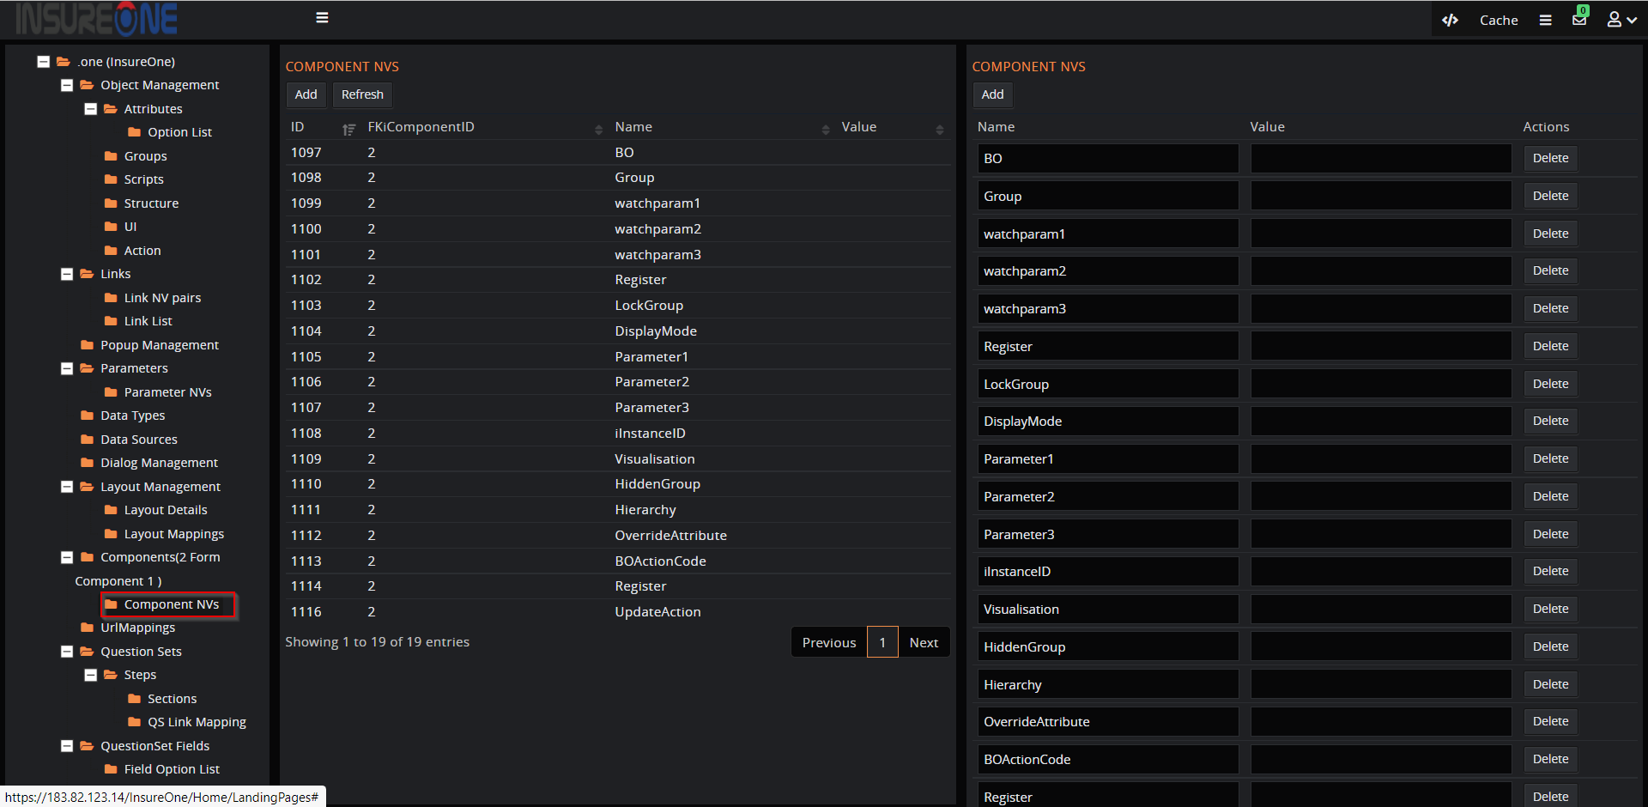

## Data Types:

Data type is an attribute of data which tells the compiler or interpreter how the programmer intends to use the data.

The data types are technical terms which can be hard for client to understand so we can create the user defined datatypes that can easily identified and used by client for example when the ‘Objects’-> ‘Attributes’ are created, we need to select the datatypes like ‘Password’ for password related fields which are mainly used while creating the question set.

The user definied data type names makes it easy for the client who doesn’t have database knowledge.

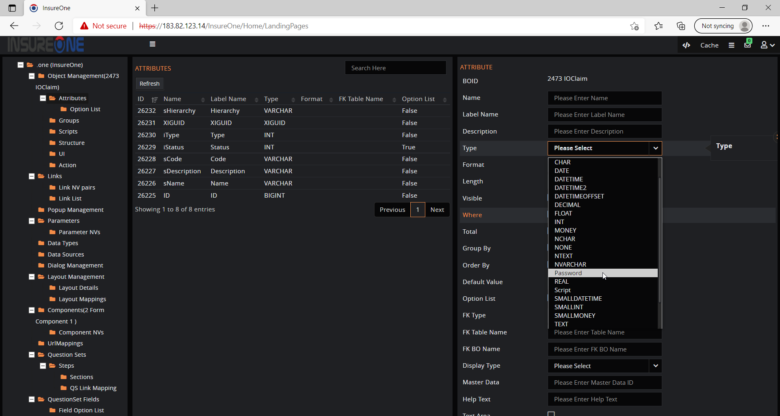

To create the datatype, click on the ‘DataType’ node and fill in the details. The datatype can be set with ‘range’ to define number of digits for example phone number that has to be restricted for 12 digits including the country code.

The regular expressions that are used for validation purpose of the datatype like datetime format, email etc with validation message also like ‘Please enter valid password’. 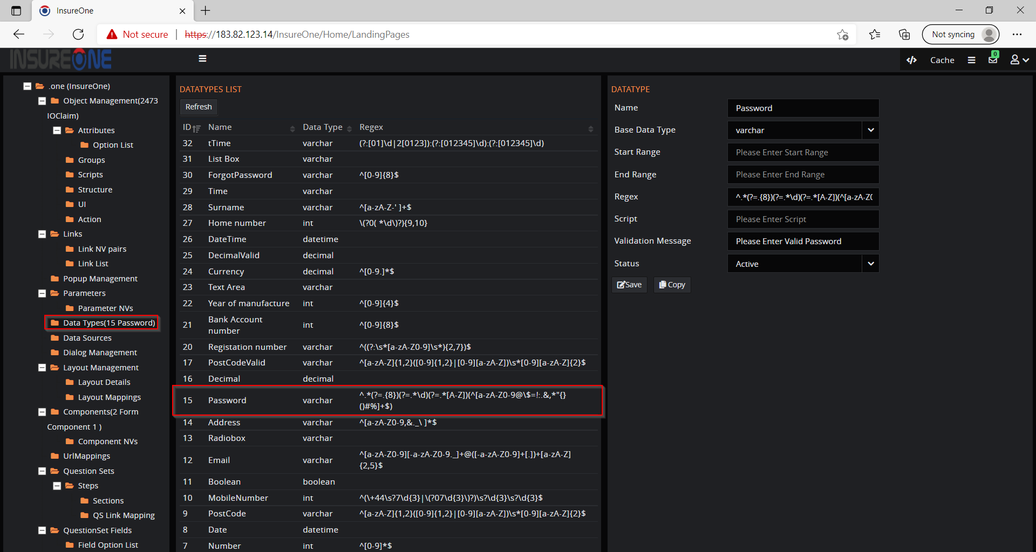

## Data source

To create application, we need to enter the database name or if left empty the database will be named based on the application by default. There are two databases ‘Core’ and ‘Shared’, where ‘Core’ stores the user roles, app settings ...etc and ‘Shared’ has the actual application data.

Creating an organization, we have two databases which is default and specific. if client choose specific database, then they will have their own database else it is default.

To create an object for the application/organisation we need to add the data source, that data source specifies connection string for the database to store the data.

When we create the application the data sources will be created by default, if not we can create the data source from the ‘Data Sources’ node by filling in the details,

* Name, name of the connection string.
* Type, connection string type like application/organisation/defined etc.
* Description, a short note on the source.
* Connection string, connection string for the database.

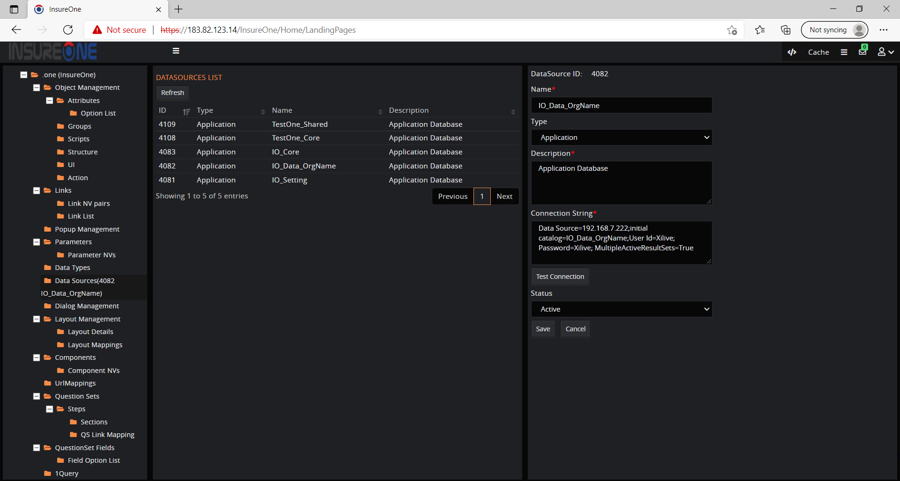

## Question Set:

The question set can be either,

1. Public Question set,
2. Internal Question set.

The question set is displayed for the client to fill the details with the maximum knowledge which is used us to generate the best quote for the customer to purchase the policy. For example, in the motorhome we have two types of the question sets like internal QS and public QS.

The question set involves two nodes,

1. QuestionSet Fields,
2. Question Sets.

First ‘QuestionSet Fields’ and related sub nodes are used to create the fields for the question set such as title, name etc. Second is ‘Question Sets that has different steps to navigate and each step has sections to which the fields are assigned.

### QuestionSet Fields:

The question set fields that are displayed to the user to fill in the details are configured here, the required fields are created and later assigned to sections.

Please note, when we create the fields follow the naming convections that defines the type, for example ‘sFirstName’ where prefix ‘s’ in lower case says the field type is string.

* ‘s’ for ‘String’,
* ‘d’ for ‘Datetime’,
* ‘r’ for ‘Float’,
* ‘i’ for ‘Integer’ etc

Question set has different types of fields:

* Fields with option list.
* Autocomplete fields.
* Dependecy fields.

#### Fields with option list:

Let’s create the new field for the question set, the field will be displayed in the question set for the client to answer and has different properties like mandatory, option list etc.

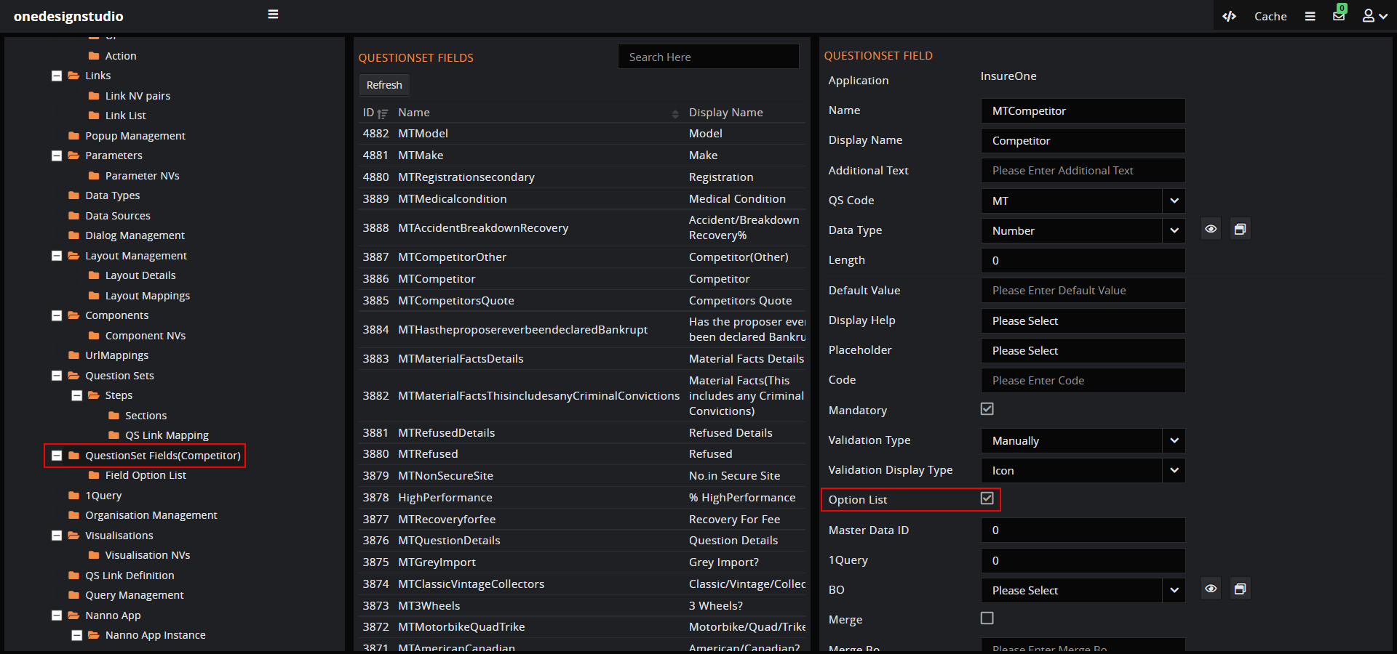

#### Field option list:

To create an option list, select the ‘option list’ checkbox on field creation, select the field and click on the ‘Field option list’ to add option list.

Steps to create an option list:

* Click the ‘Add’ button to add multiple option list.
* Enter the option name and value and click on ‘Save’ button.

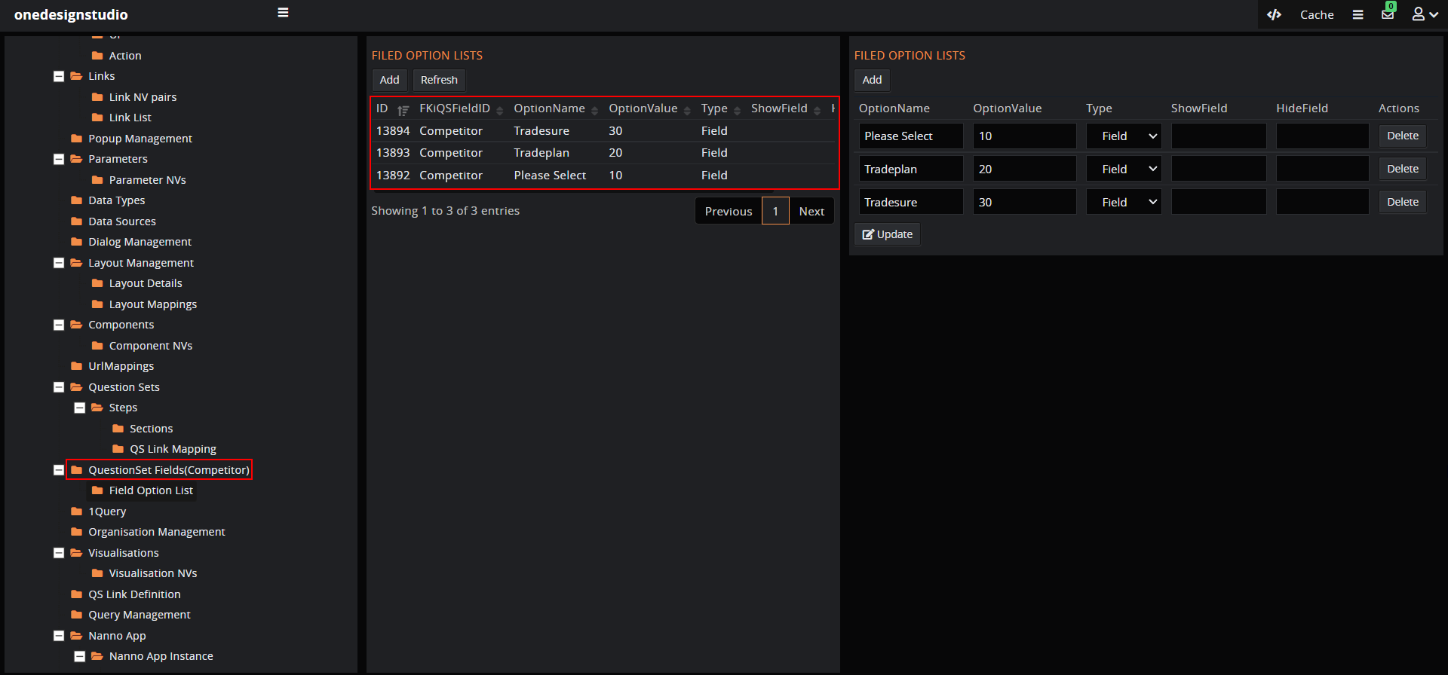

#### Autocomplete fields:

Some fields in the questionset that are autocomple which can be configured using the 1-click ID and object name.

Follow the steps below:

Step 1: Create an object, the name which will be added in the question set field.

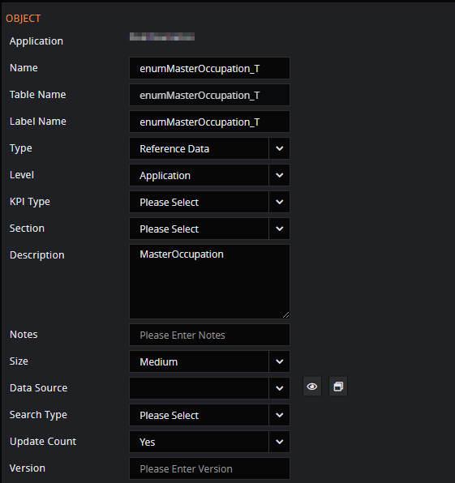

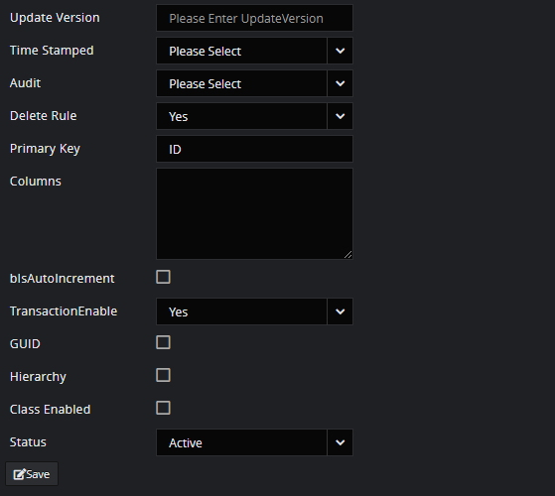

Step 2: Create the 1-Click query which is basic query, the 1-click creation will be explained in separate section.

Step3: Create a ‘Questionset Field’ with details to create a autocomplete field with 1-Click ID and object name..

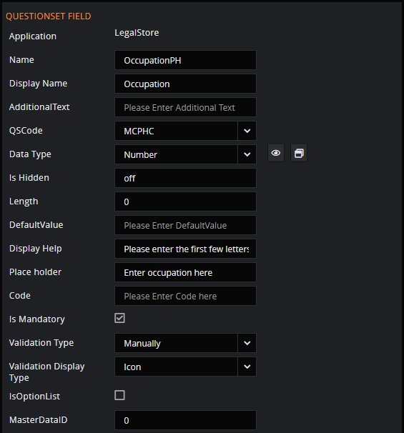

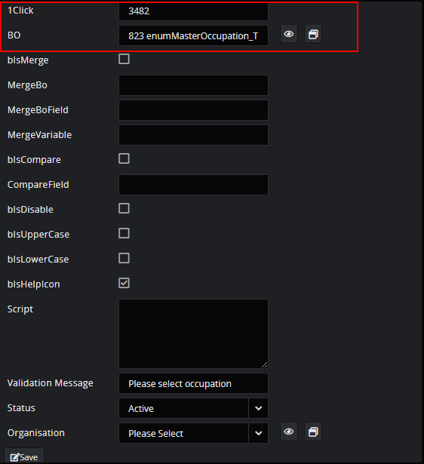

#### Dependency Fields:

Field dependencies are filters that allow us to change the contents based on the value of another field.

For example, in the ‘Cohabitation Breakdown’ the depency field is ‘Who owns the property in dispute?’ which on selecting ‘Owned by other’ displays other fields.

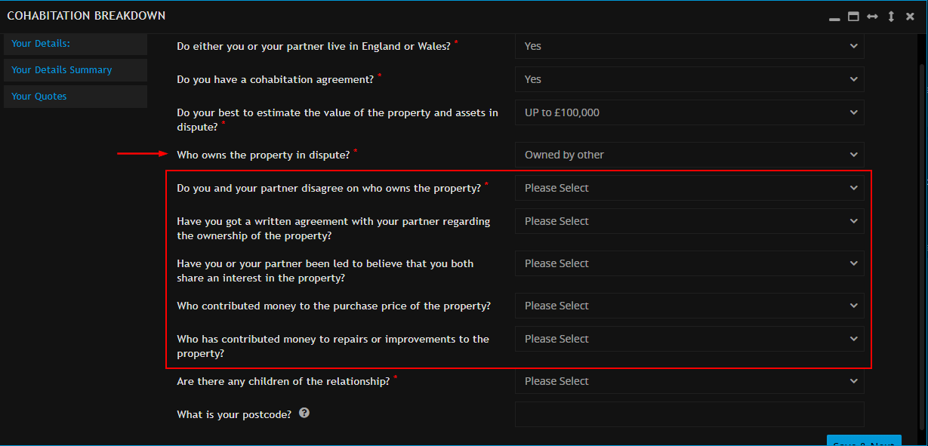

The steps to create the dependency fields include:

Step 1: Create main field to display dependency fields. Click on ‘Questionset Field’ to create field with option list set as true.

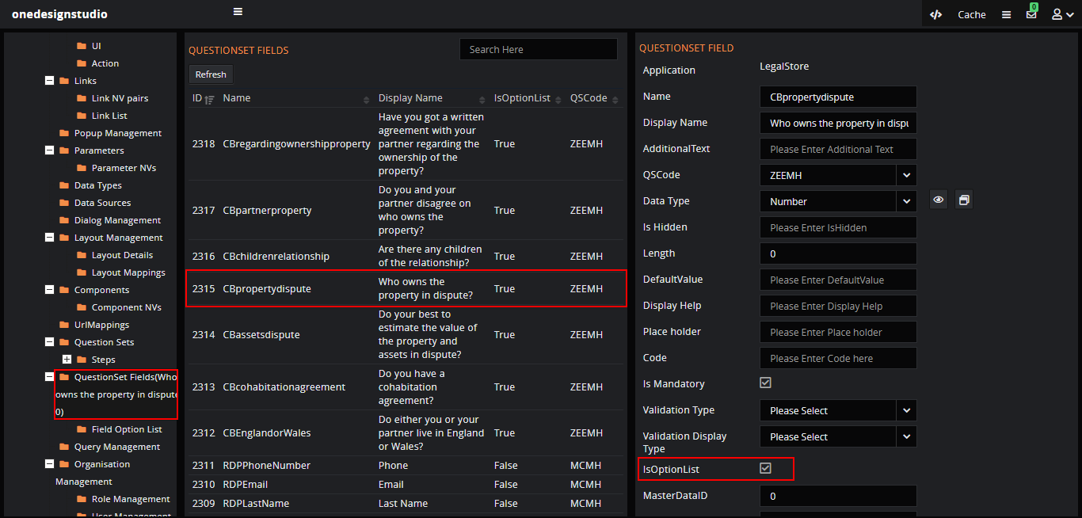

Step 2: Create other fields from the ‘Questionset Fields’ that will be hide/show based on the values selected for above main field.

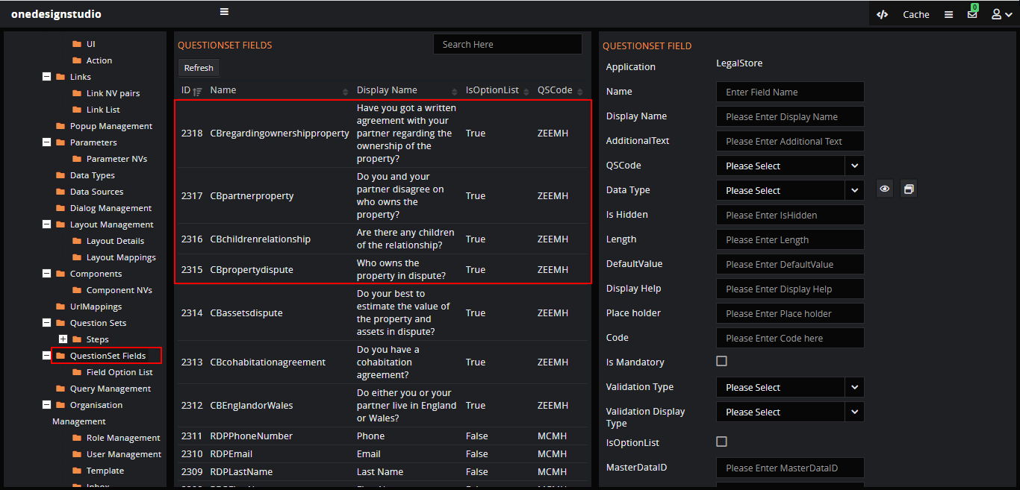

Step 3: Create the option list for the main fields in ‘Field Option List’ and there we can assign the ‘Section Code’ name for the ‘section’ created with fields assigned and hidden set to ‘true’ in steps section (Explained in ‘Hide Section’ below) that has fields to hide/show based on the value selected.

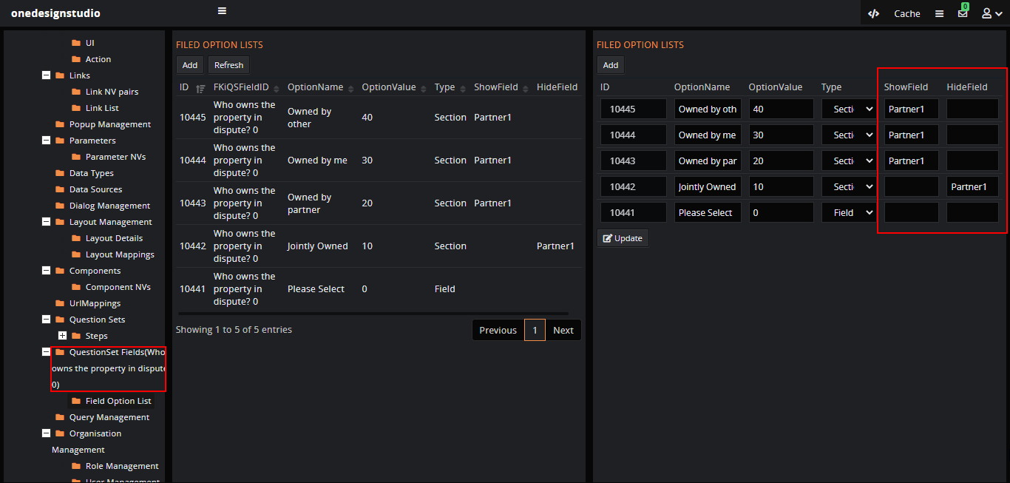

### Question set:

The question set will be displayed as steps, for example ‘Your Needs’, ‘Your Details, ‘Summary’ etc and each steps has sections.

To create a step and sections we need to create the question set from the ‘Questionset’ node.

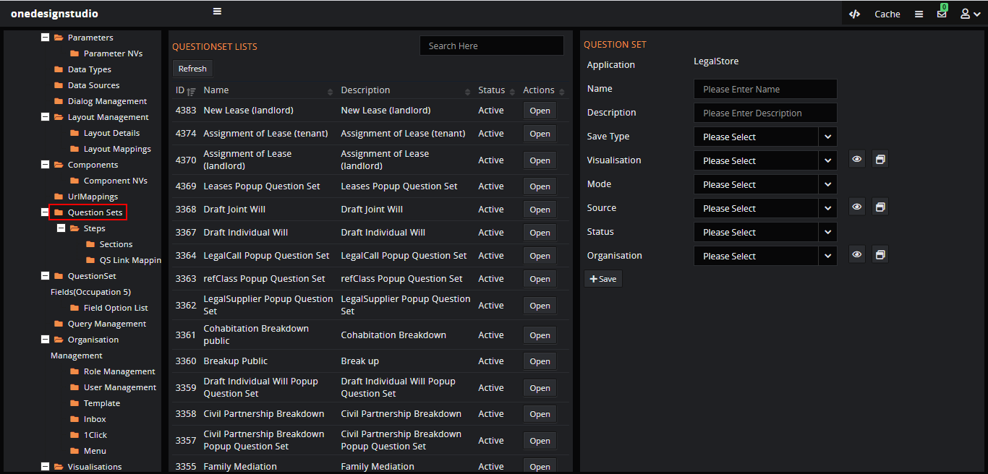

Enter the details to create the question set.

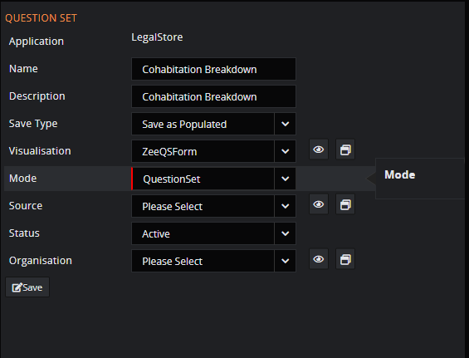

#### Create Steps:

In the ‘Questionset’, select the question set to which the steps will be created. Expand and click on the ‘Steps’ sub node to create new step for the QS, for example ‘Your details’ step in question set.

Any number of steps can be created for the question set.

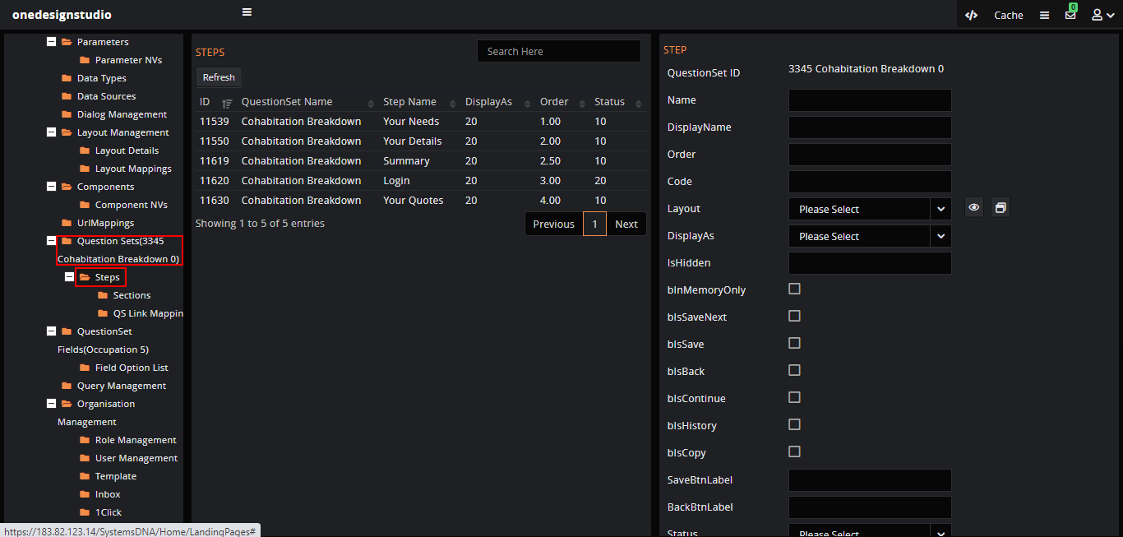

Fill in the details and ‘Save’ that will create the step, the steps can be added with order to display, step contains the sections with buttons like ‘Save’, ‘Back’, ‘Save&Next’ etc

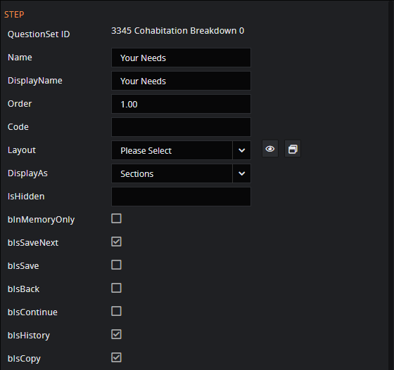

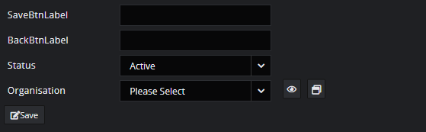

#### Create section:

Each step can have number of sections, to create the section select the ‘Step’ and expand to click on the ‘Section’ node to create a new section.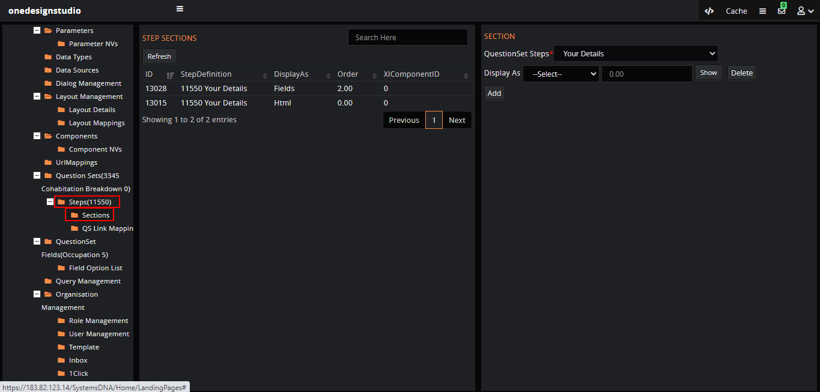

The section can also have a description to the page which will be created as html. Click on the ‘Add’ button to create new where the section that will be displayed as html text above the QS fields so ‘Display As’ will be ‘HTML’ and ‘Order’ will be ‘1’.



Click on the ‘Show’ button to add the content.

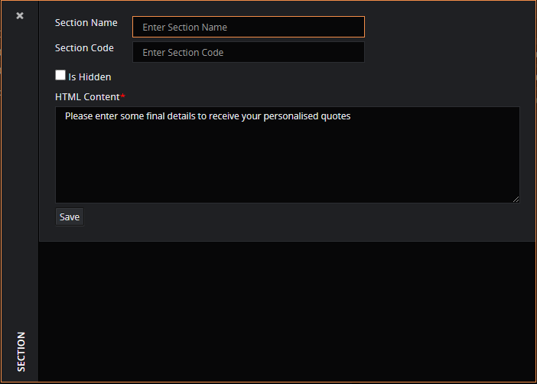

Next, we need to select what has to be displayed in the section for example ‘Fields’ so the step will display section with fields like ‘Title’, First Name’, ‘Last Name’ etc are assigned here.

Select the ‘Display As’ value as ‘Fields’ as we are going to display the fields and ‘Order’ as ‘2’ as we are displaying the fields after we display the description.

Click on ‘Show’, assign fields created using ‘Questionset Fields’ and save the details.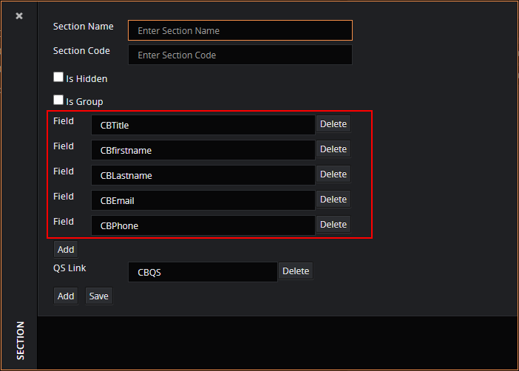

##### Hide Section:

In a step if the part of section with fields has to be hidden and displayed based on the values of fields then ‘Is Hidden’ is set to true.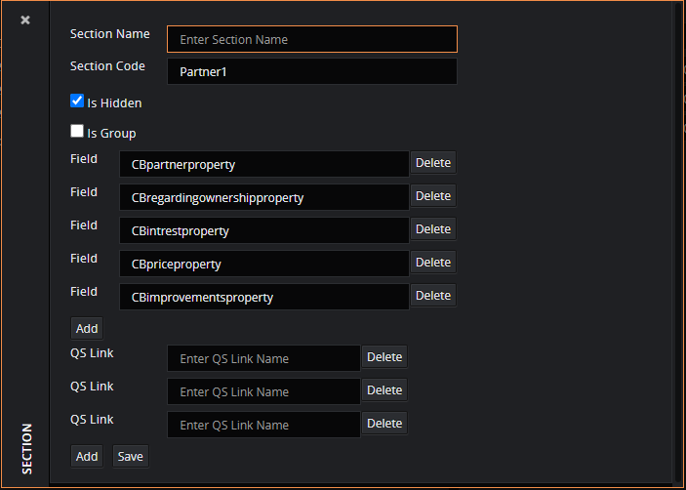

For example, in ‘Cohabitation Breakdown’ question set the step ‘Your needs’ has section in which few fields are hidden as its depended-on value of other field.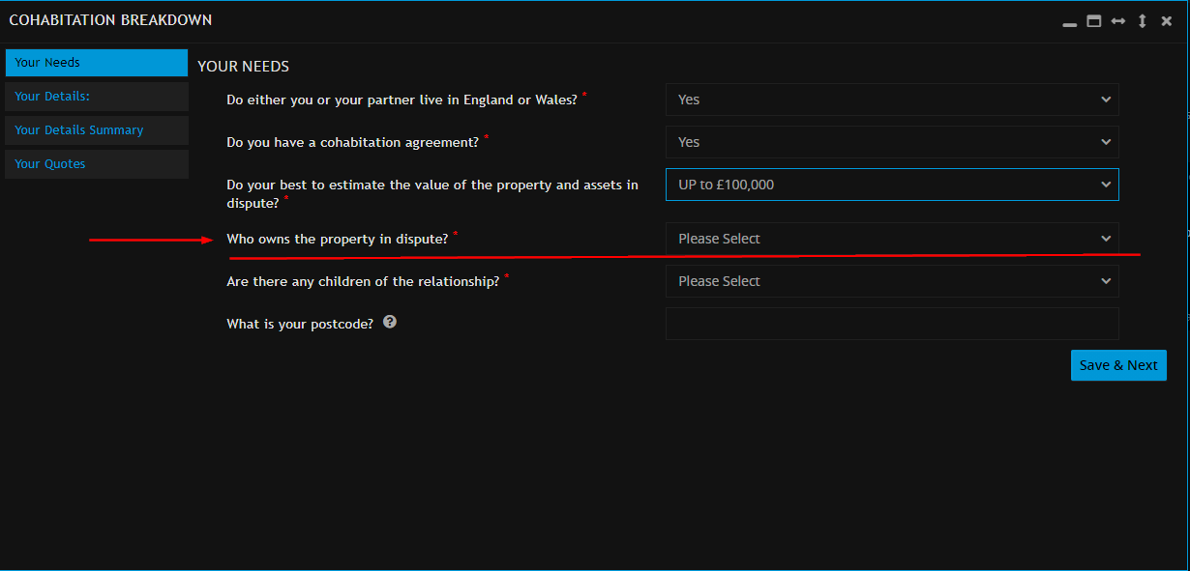

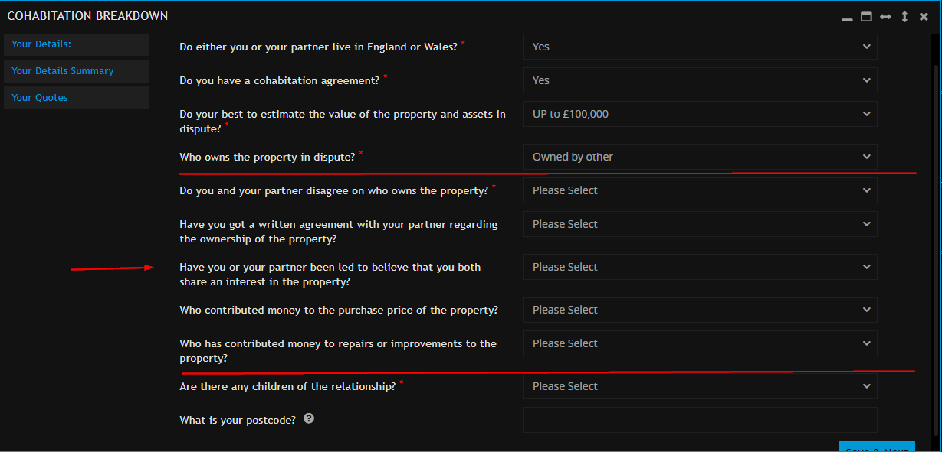

##### Summary:

If the step is a ‘Summary’ page it will be configured differentially from normal steps in ‘Section’ using components.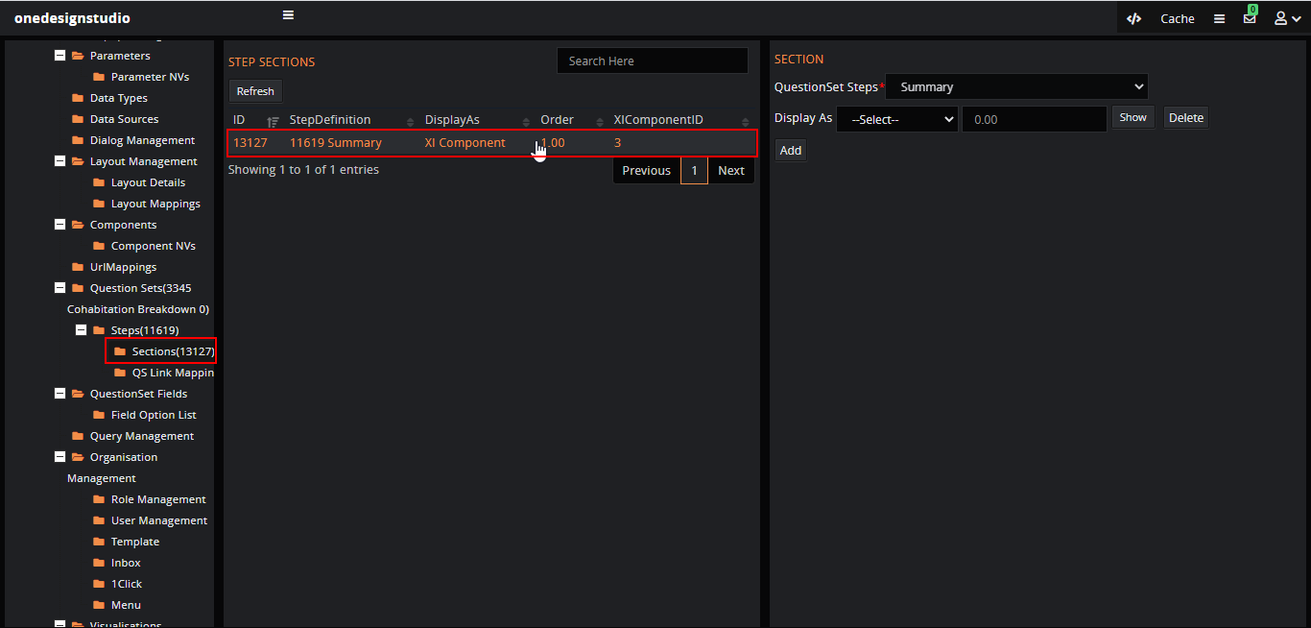

Select the ‘Display As’ is ‘XIComponent’ then the ‘Show’ button has the form with extra fields.

  
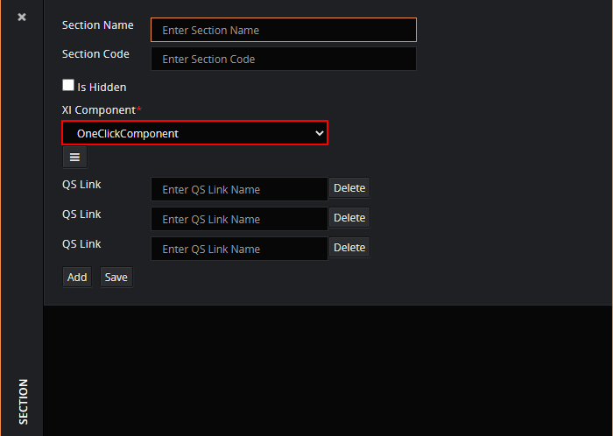

Click on the hamburger icon, enter the ‘1-Click ID’ and ‘visiualisation’ for the section.

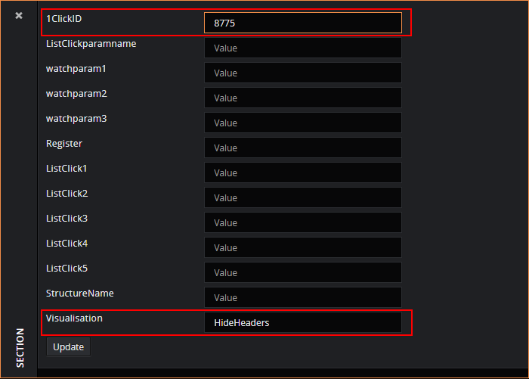

##### Quotes:

To display the quotes,

* Create the ‘1-click’,
* Create a structure for object,
* In “Questionset”, “Steps” create a new step “Your Quotes”.

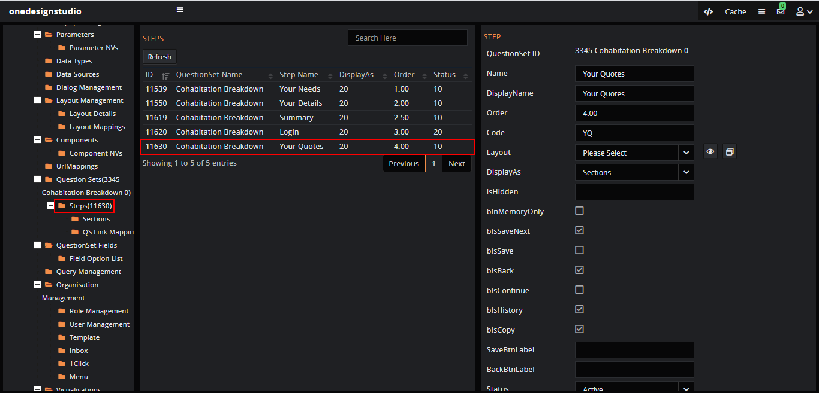

Add the section details for the step from “Sections”.

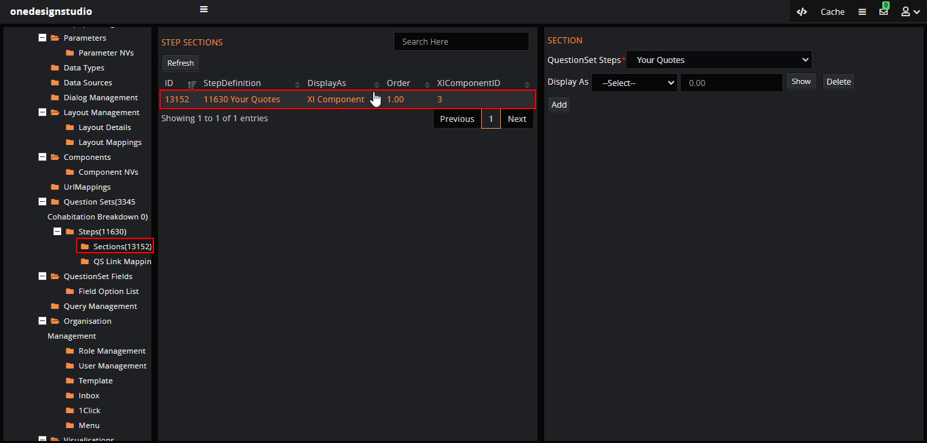

We need configure Qs step, select ‘Display As’ as ‘XI Component” and click on the ‘Show’ button.



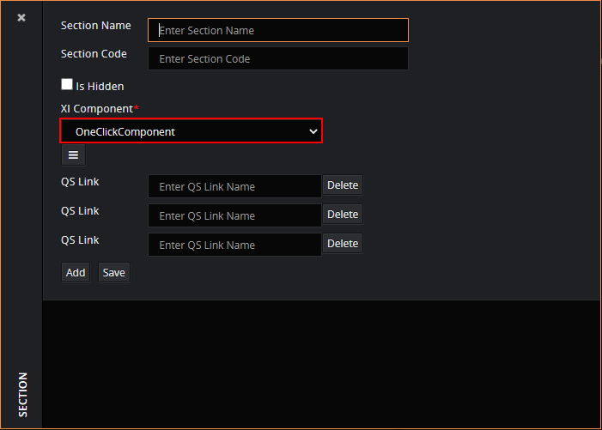

Select the XI Component as “OneClickComponent” and click on the hamburger icon to add the ‘1-Click ID’, structure name and visualization. 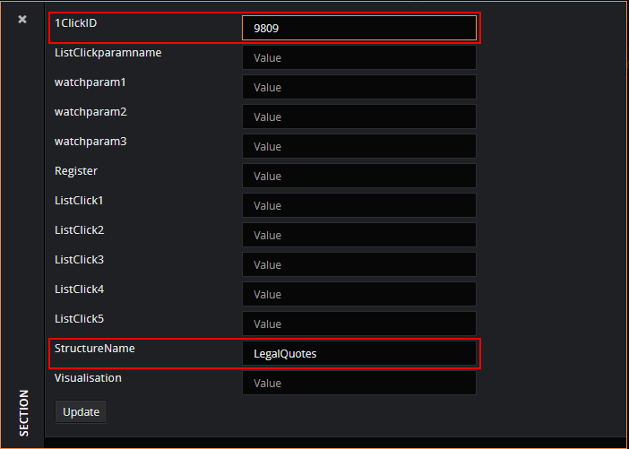

*Note: The config template has to be created from the backend for now.*

### QS Links:

The QS links are created to save the question set details to the related table, the step ‘Your details’ has the lead details to be saved to the object with table ‘LegalLeads_T’.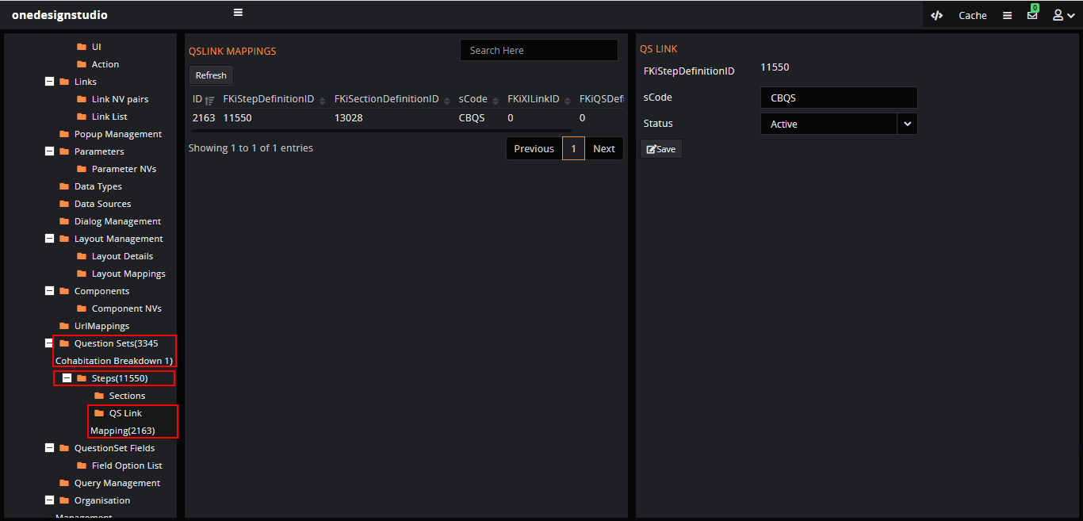

The code in the QS link triggers the process controller, The QS Links has the code i.e., ‘sCode’ with value as ‘CBQS’, click on the ‘QS Link Definition’ node in tree to check the definiton for the code which contains process controller.

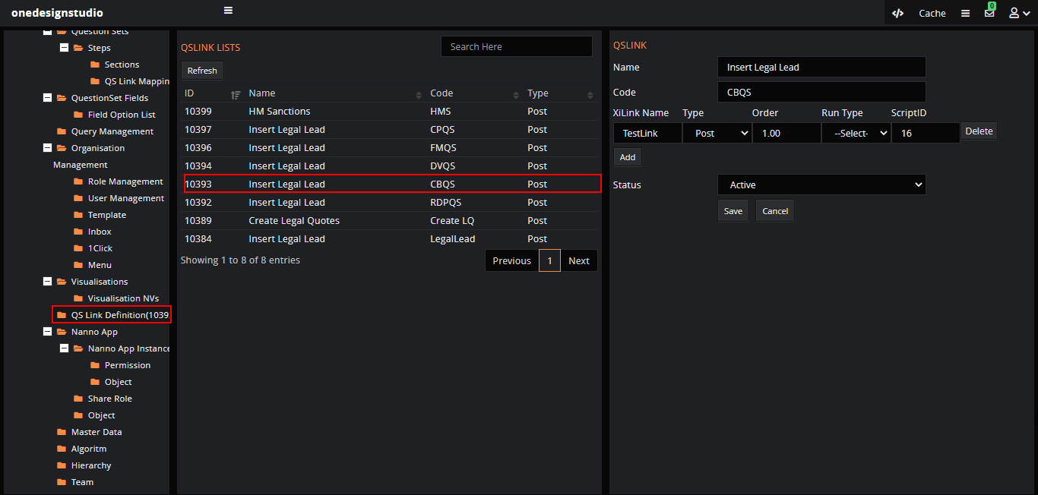

The QS link is added to the step section details.

## List view in Question set:

In some cases, for a section in the question set, if the requirement is to add the multiple details like drivers, convictions etc then we need to display the details and edit if required to make this easy lets add the list view with row edit option. The ‘Add’ button will display the form to add the details and once the ‘Save’ biutton is clicked the details will get displayed in the list and click on ‘+’ button on each row to edit.

To create the list view with add/edit option lets follow the step below.

1. Create the object for the question set type.
2. Add attributes for the object.
3. Add option list for the attributes if required.
4. Create the group (ex ‘Create’ group and add the attributes where ‘ID’ is default.).
5. Create the 1-click and add details in actions to display the button.
6. Create QuestionSet Fields, Questionsets with steps and sections.
7. Add the 1-click ID to the section with display type as ‘XIComponent’.

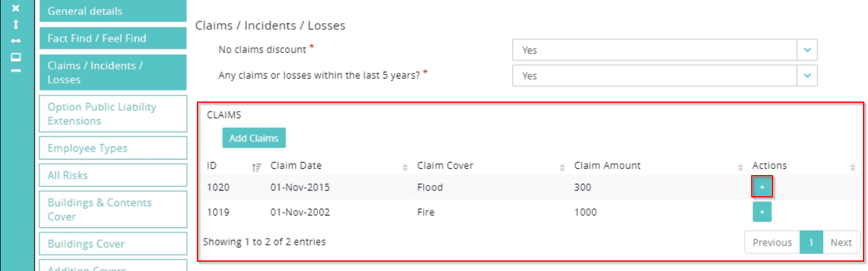

# Configuration Studio:

The configuration studio is used to config menu, 1-clicks etc for the related organisation, the default organisation is having the same name as the application but it may be different in other cases, go to the application url(<https://183.82.123.14/InsureOne/ApplicationName>) enter the name of our application instead of ‘ApplicationName’ and login with credentials the ‘Username’ has the prefix ‘cs’ at the start.

## Menu:

In the application to display the question set we need to add the menu which on click will show the question set steps with sections. Click on the ‘Menu’ node to create menu/sub menu.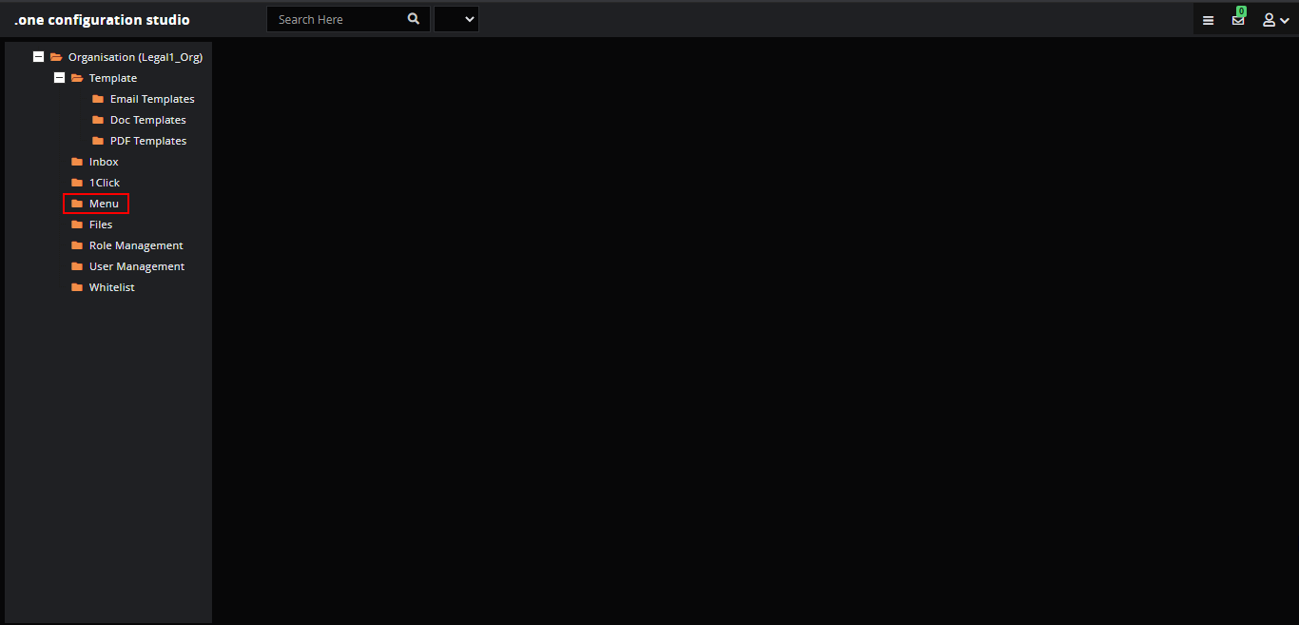

Click on the ‘Add’ button to create new menu or click on the existing menu to create the sub menus.

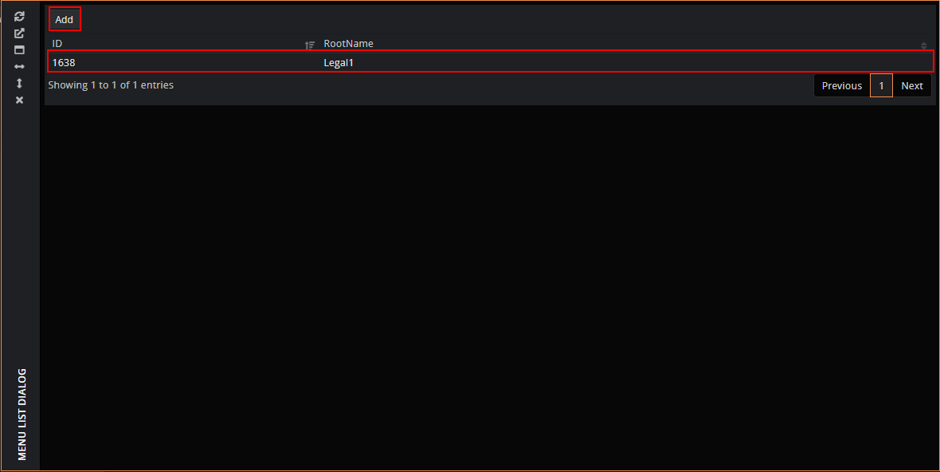

Click on ‘+’ to expand the list of menu.

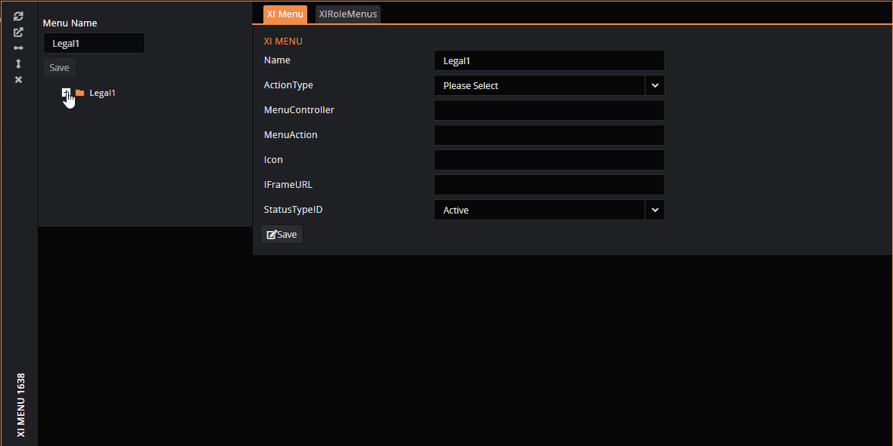

Right click on the node to create, rename, remove menu.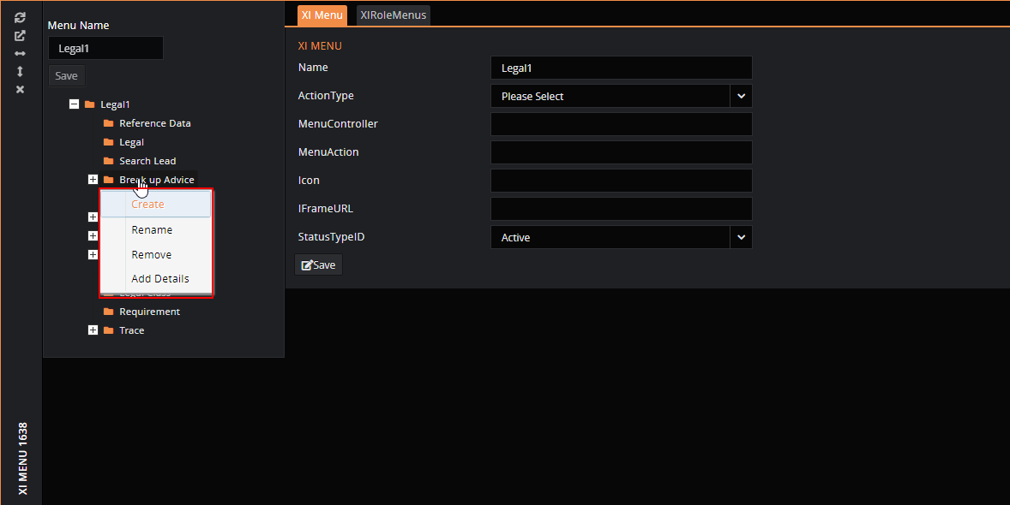

### Map menu:

We can map details to the menu created, for example to display the question set on menu click we need to map the xilink for dialog as xilink for QS is mapped to layout.

To map the details right click on the node, ‘Add Details’ to map the xilink ID created for the dialog.

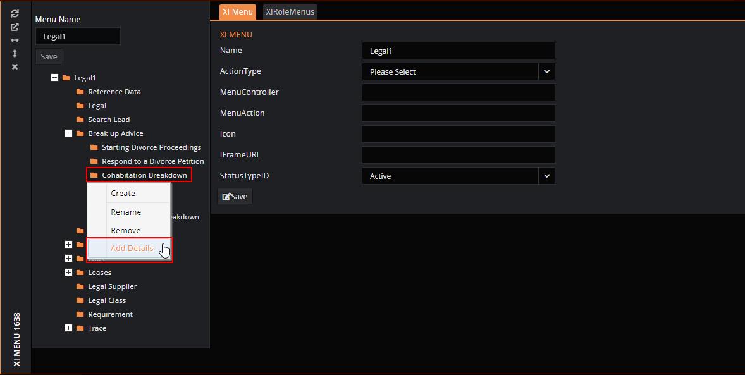

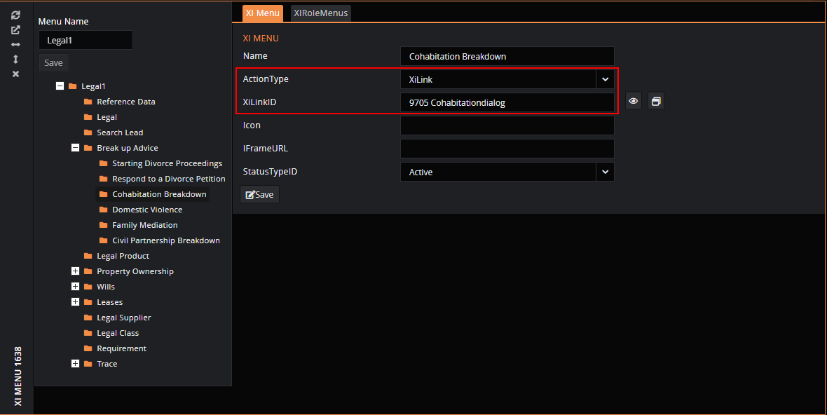

## 1-Clicks:

Login to ‘.one Configuration Studio’ and click on the ‘1Clicks’ node.

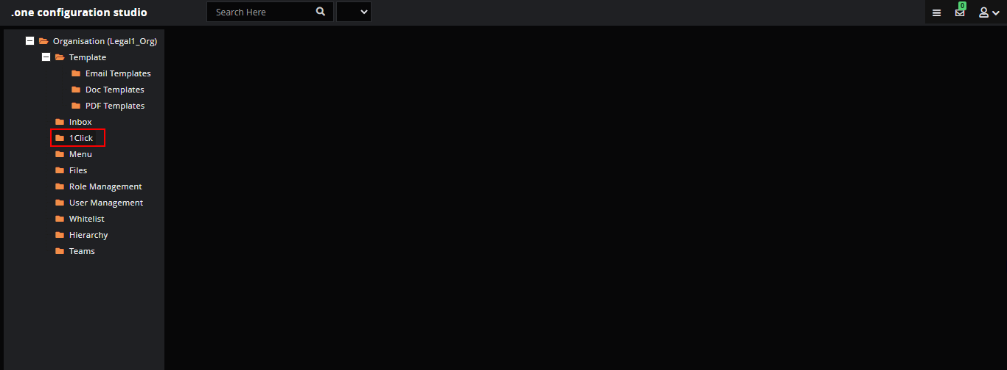

Click on the ‘Add’ button in the dialog to create new 1-Clicks.

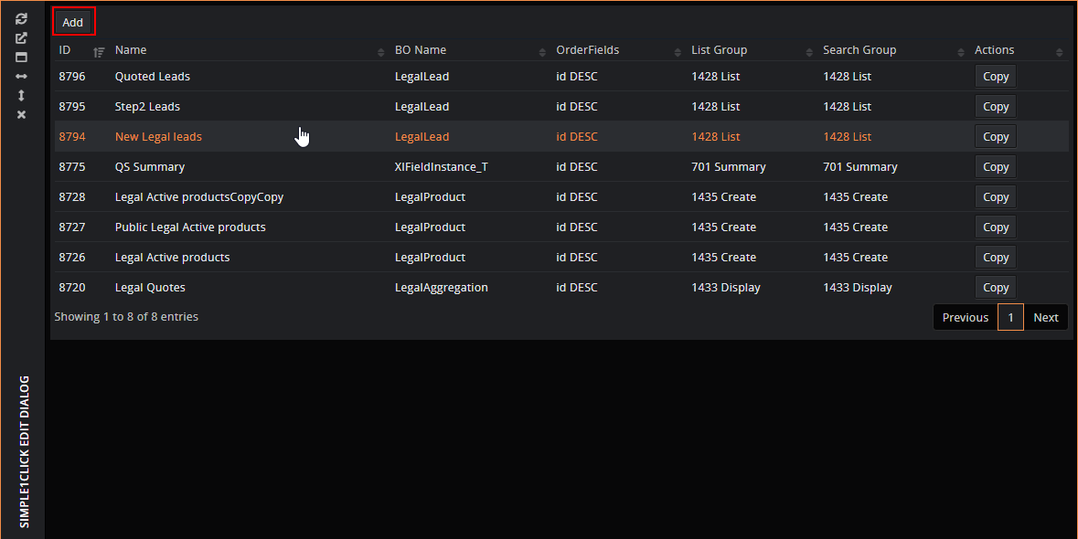

Fill in the details.

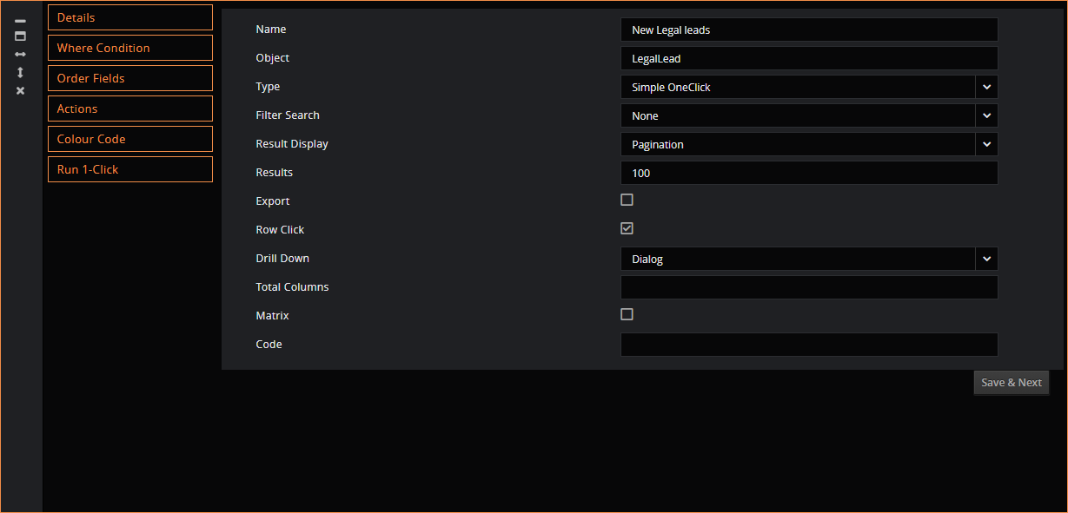

Add the ‘where’ condition, for example select the lead with ‘Status’ as ‘New’.

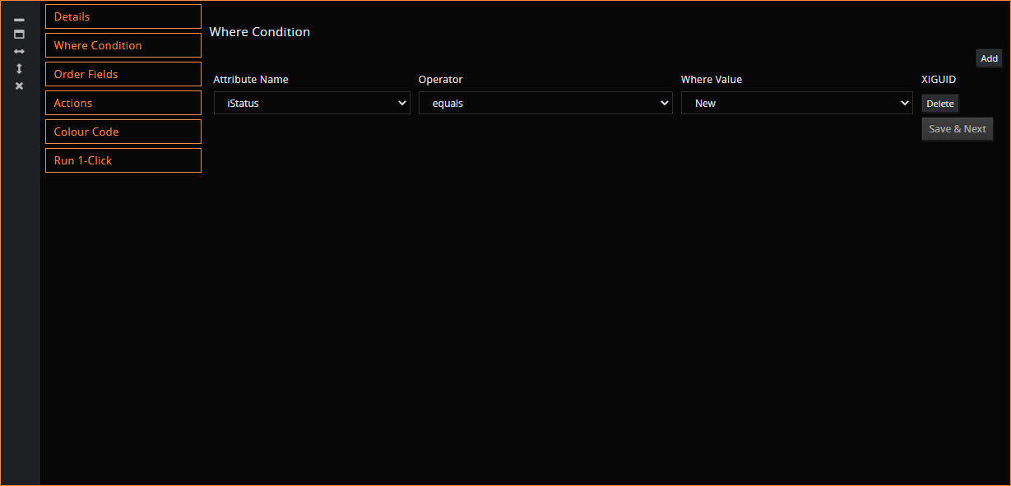

Order the query result on ‘ID’ in descending order.

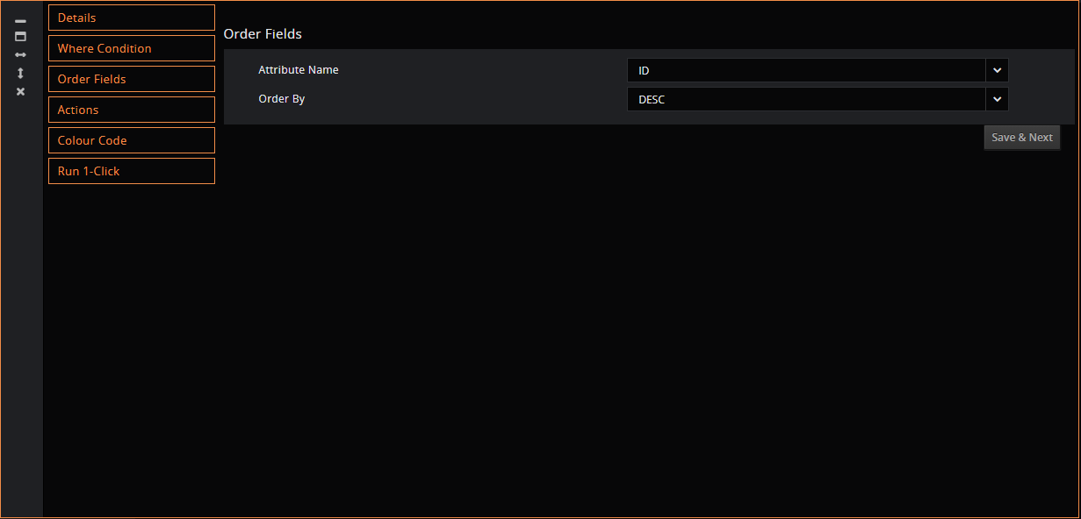

Add color code to the result based on the conditions.

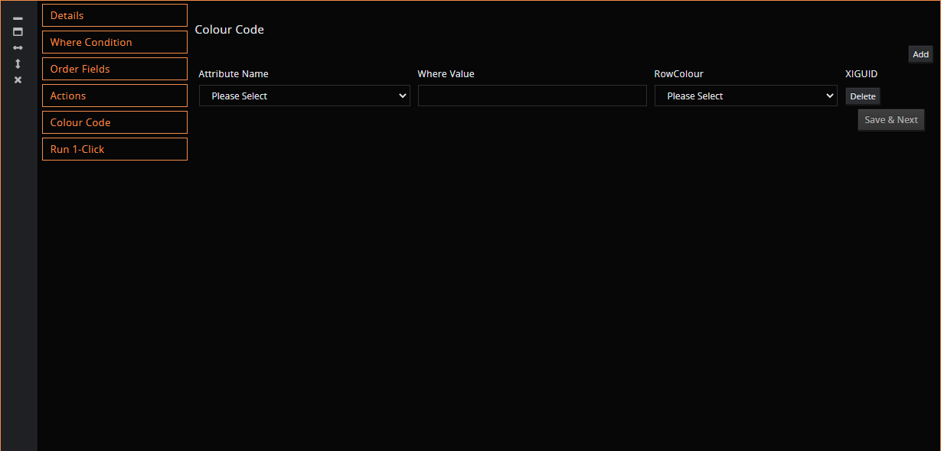

Last step is to verify the query created by executing to check the result.

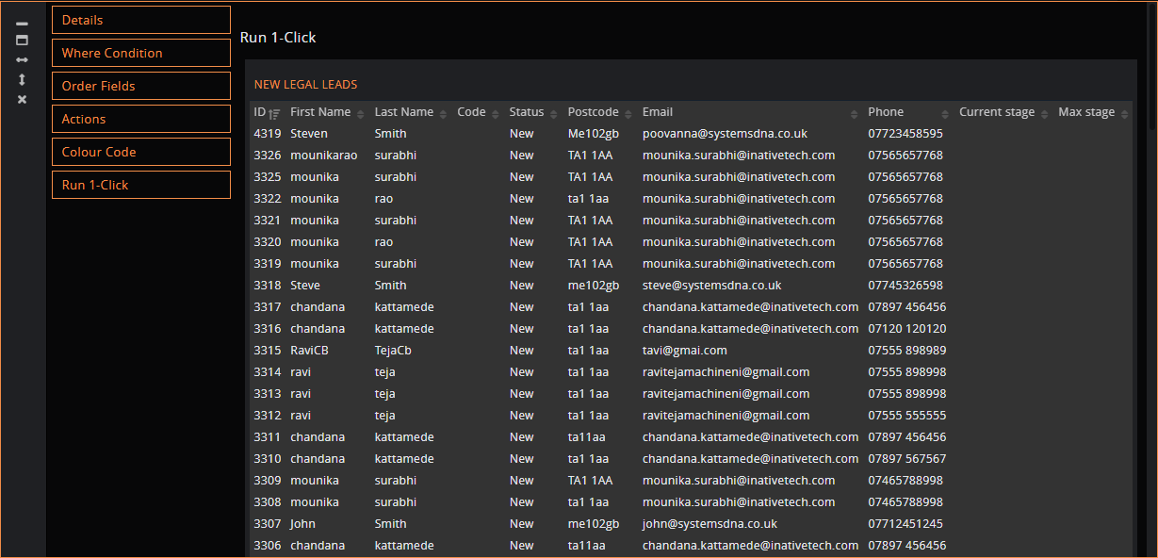

The 1Click created will get displayed in the grid.

